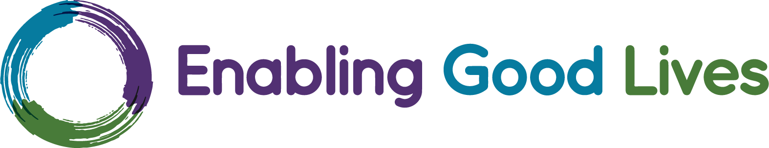
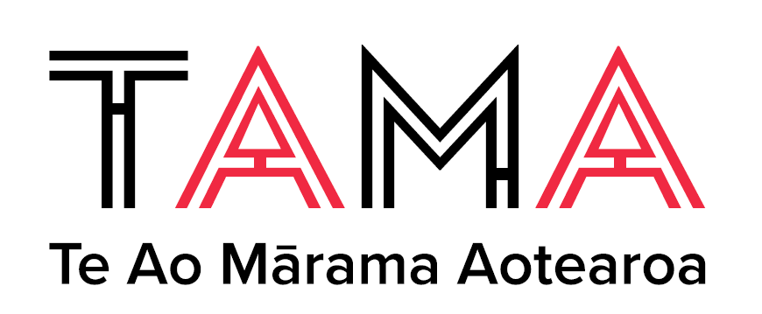
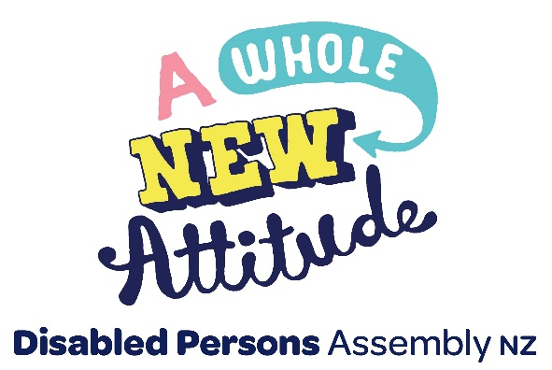

Information about the

Finding Common Ground survey:
Declaration of Disabled Peoples Rights in Aotearoa New Zealand

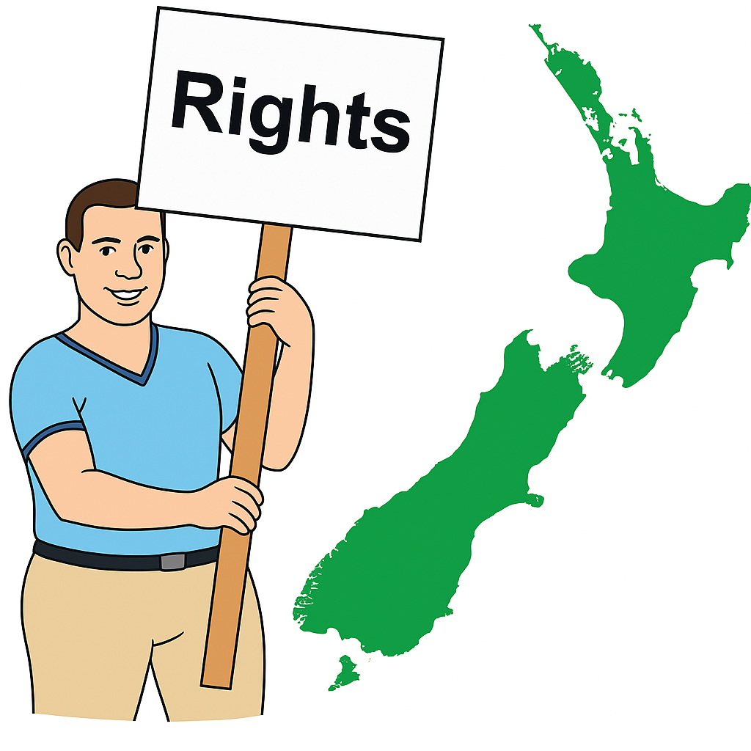

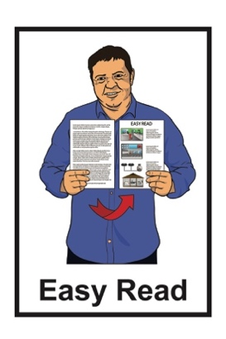
Published: May 2026

What you will find in here


Page number:

About this Easy Read 2


What is Finding Common
Ground? 4

What is Finding Common Ground
doing? 6

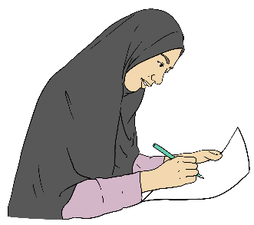
What you say is important 11


What we will do with your survey answers 12


How to do the survey 16

Where to find more information 17

About this Easy Read

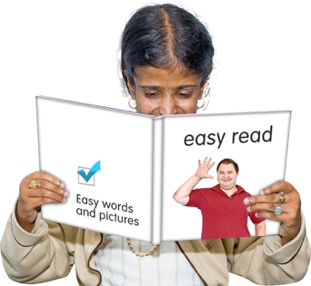
This Easy Read is information about how you can do a survey from Finding Common Ground.


A survey is a list of questions that you can answer.

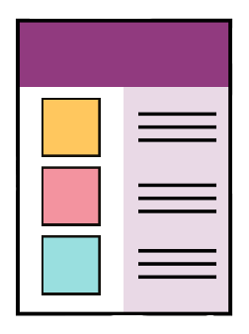
Information about Finding Common Ground is on pages 4 to 5.


Where it says we / us in this Easy Read it means Finding Common Ground.

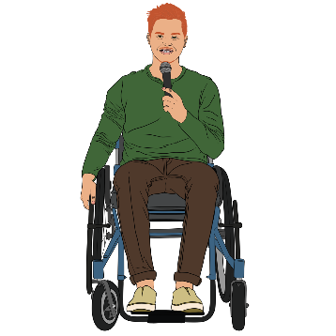

The survey asks you questions about what you would like put in the Declaration of Disabled Peoples Rights in Aotearoa New Zealand.

Information about the Declaration of Disabled Peoples Rights in Aotearoa New Zealand is on pages 5 to 9.



In this Easy Read the Declaration of Disabled Peoples Rights in Aotearoa New Zealand will be called the declaration.

What is Finding Common Ground?

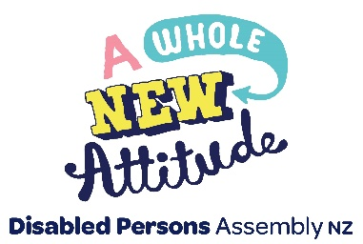
Finding Common Ground is an initiative from:
Disabled Persons Assembly New Zealand / DPA

National Enabling Good
Lives / NEGL
Te Ao Mārama Aotearoa Trust / TAMA.

Here an initiative is a group of people working together to do something important.

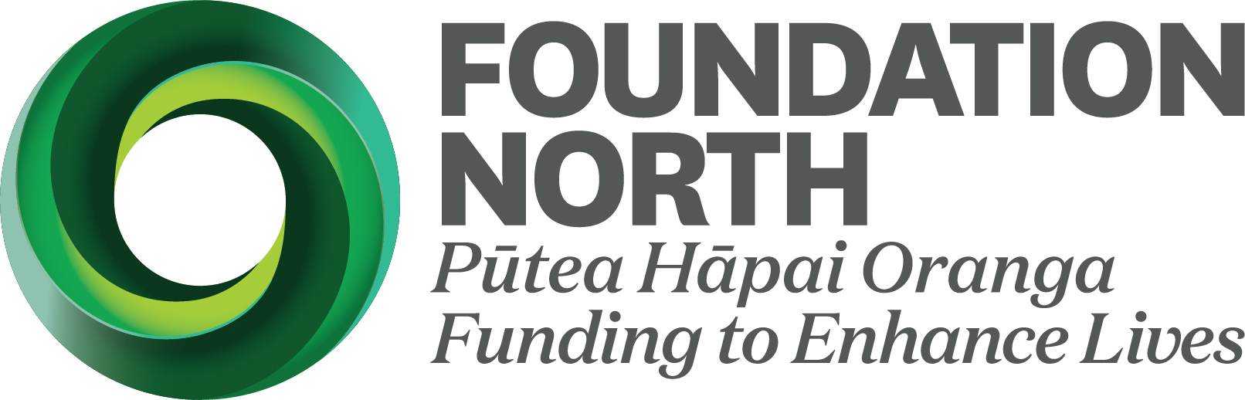
Finding Common Ground is
funded / gets money from:
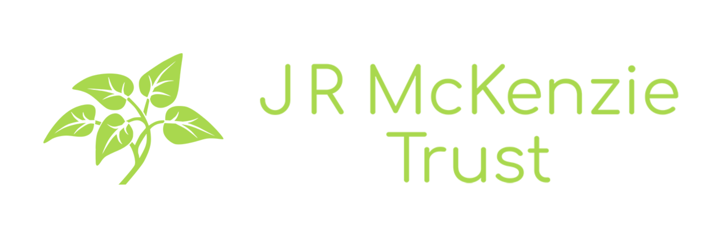
Foundation North
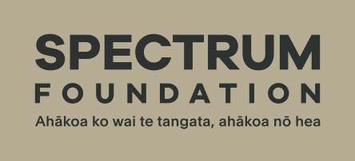
J R McKenzie Trust
Spectrum Foundation.


You can read more about Finding Common Ground at this website:

www.dpa.org.nz/dpa-projects/
finding-common-ground/
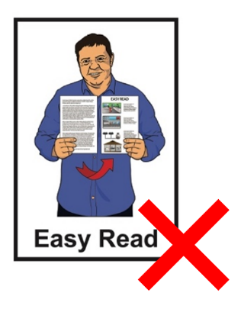

This website is not in Easy Read.

What is Finding Common Ground doing?

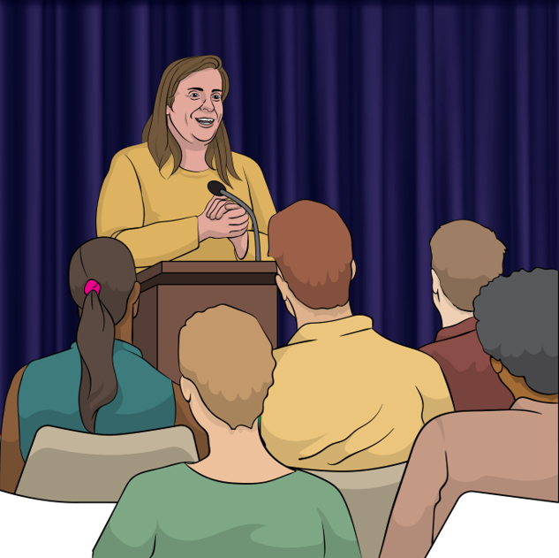
Finding Common Ground is working to make a Declaration of Disabled Persons Rights in Aotearoa New Zealand.

Here a declaration is a
statement / words about how:
important something is
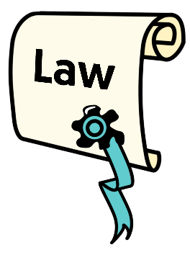
something must be taken care of by:
- the law
- everyone in New Zealand.

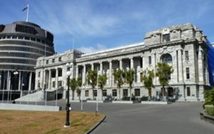
A law is a rule made by the government that everybody must follow.
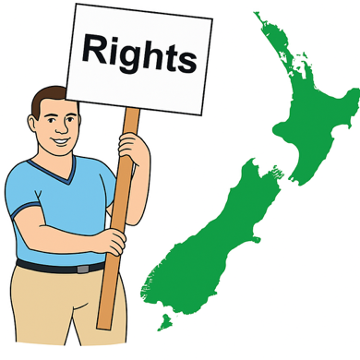
Rights are things that the
law says every person should:
have
be able to do.


Rights are things like:
having a safe place to live
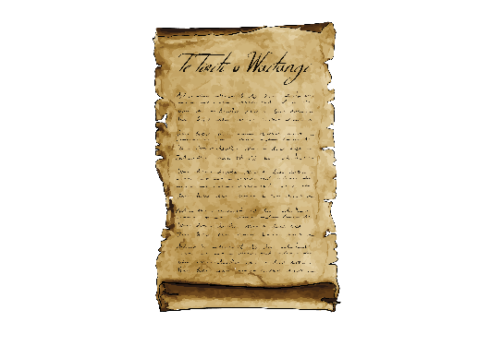
getting the health care you need.

The declaration will use the ideas in:
Te Tiriti o Waitangi / the Treaty of Waitangi

the United Nations Convention on the Rights of Persons with Disabilities
Enabling Good Lives.

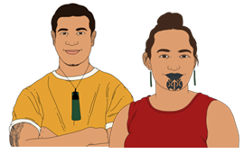
Te Tiriti o Waitangi / the Treaty of Waitangi is an important agreement between:
Māori
and
the Crown.

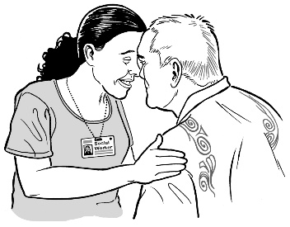
The purpose of Te Tiriti is to:
protect Māori:
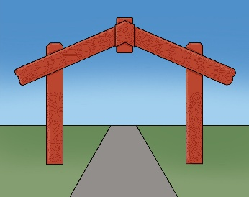
- rights
- taonga
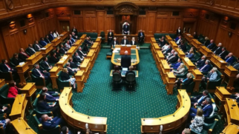
keep peace and order
set up government.
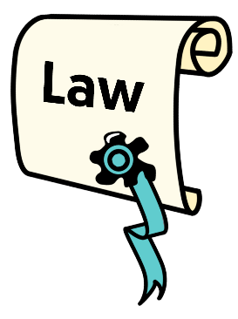

Keep peace and order means to follow laws / rules.
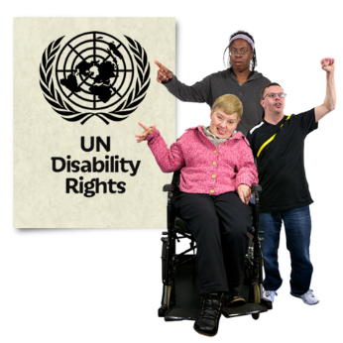
The United Nations Convention on the Rights of Persons with Disabilities is a law lots of countries have agreed to.

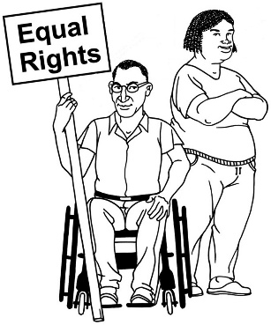
It says what governments must do to make sure disabled people get the same rights as everybody else.


Enabling Good Lives is a different way of thinking about disability support.

Enabling Good Lives is about having:
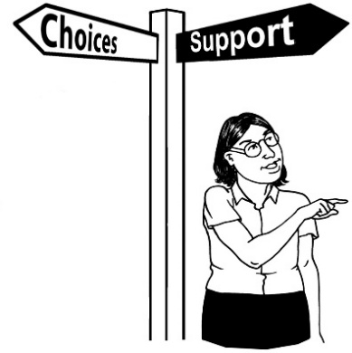
choice and control in your life
the support you need and want
a good life.

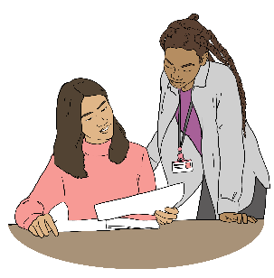
Any draft declaration we create will be shared so people can give their feedback on it.

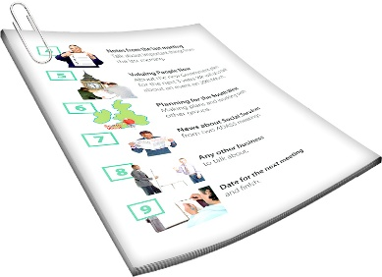
Here a draft is the first version of a document.

Changes are made to a draft before
it is a finished document.

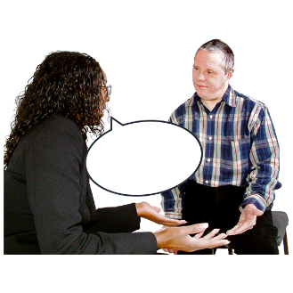
Feedback means telling someone what you think about something.

What you say is important


Change is best when we do it together.


This survey will support us to find different ideas for making the declaration.

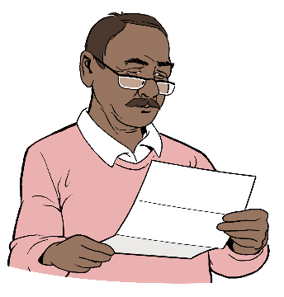
To do the survey you do not need any experience with other declarations.

What we will do with your

survey answers


What you tell us in the survey will be:
stored securely / kept safe
only used for this
project / declaration
only seen by people who are part of the project / declaration.


You can find out how the information you share with us will be used here:

https://tinyurl.com/22ckuhxd
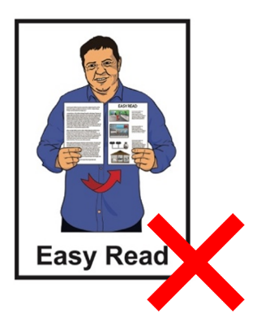

This information is not in Easy Read.


We will:
look at what you say in the survey
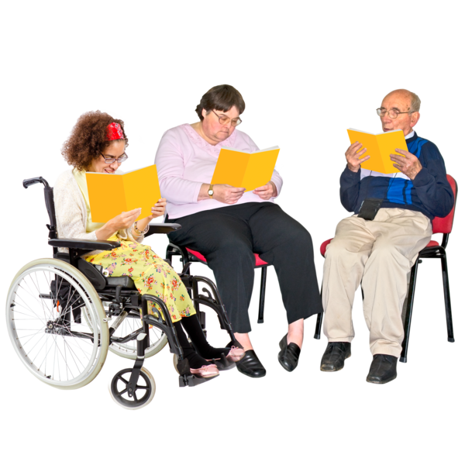
take ideas from other:
- declarations
- sets of rules.

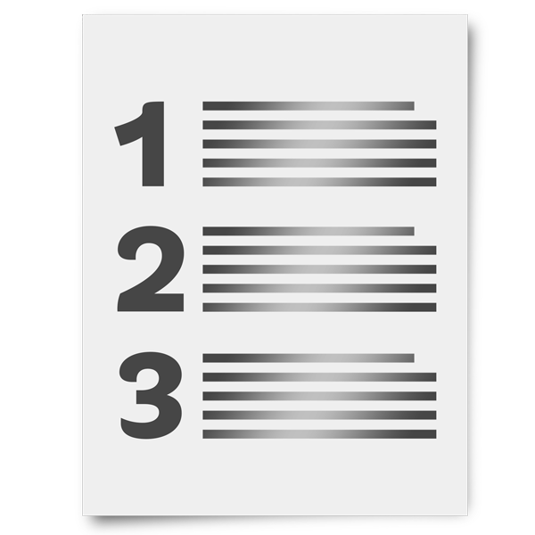
We will make options / choices to go in the declaration with this information.

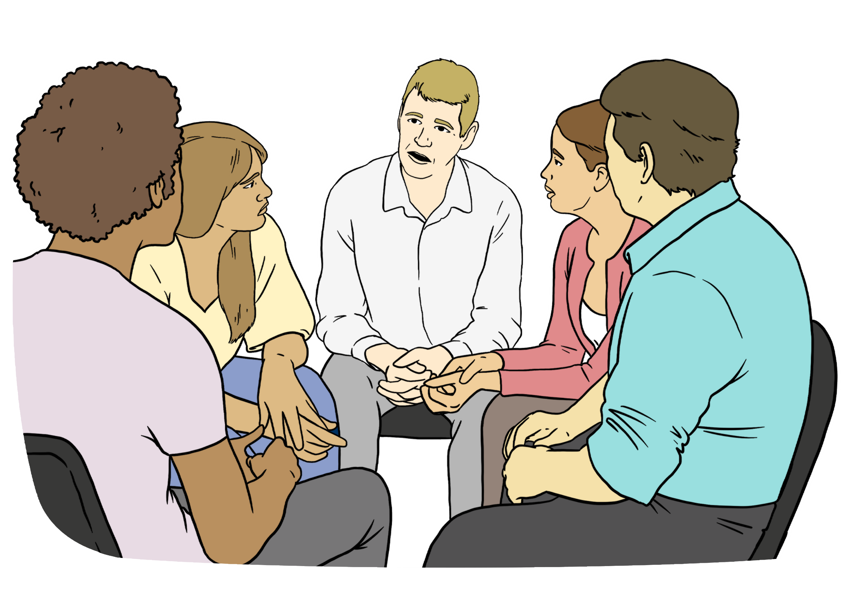
We will then hold meetings with the disability community to find out what options / choices you think are the most important.

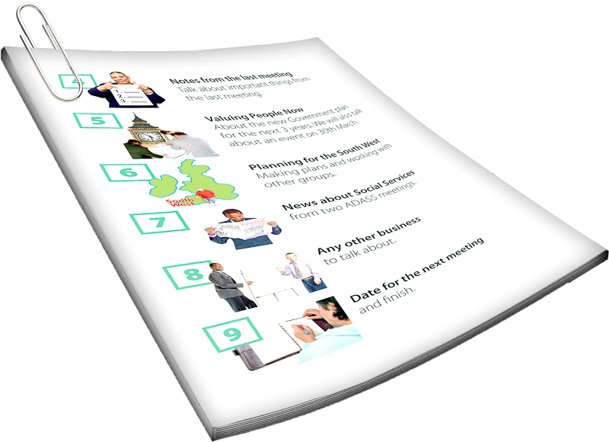
We will then make a draft declaration.

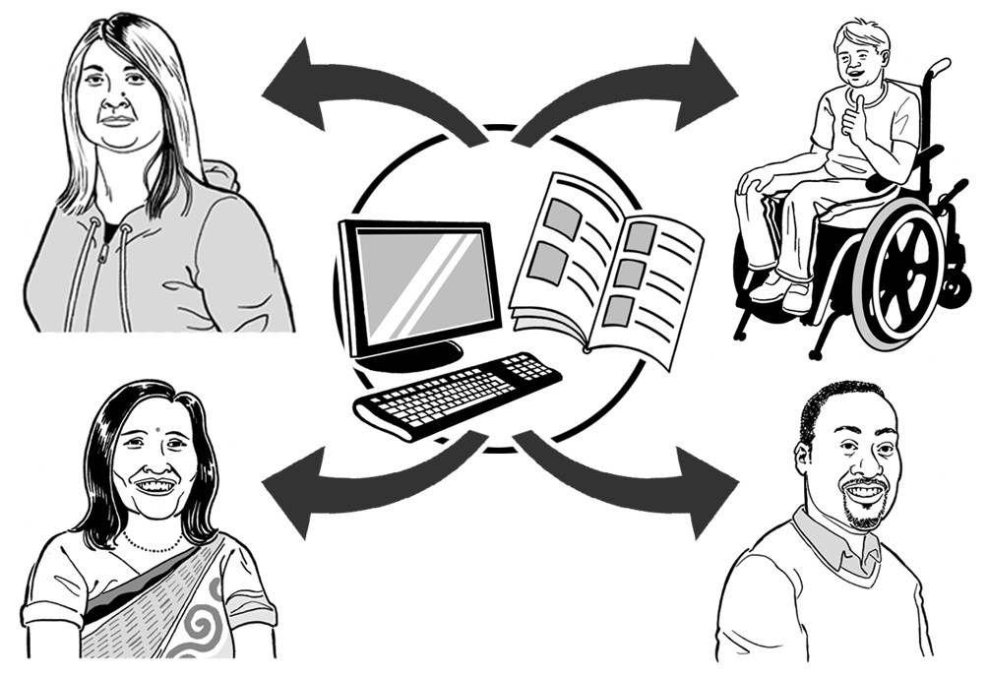
The draft declaration will be shared with people to get their feedback on it.

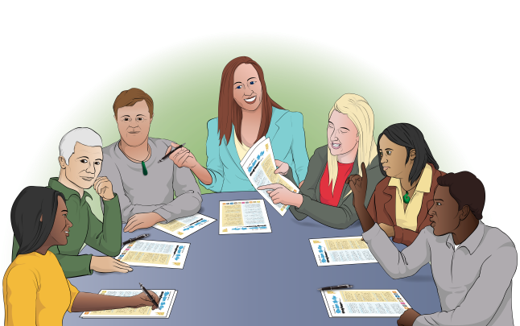
The declaration will then be finished by our steering group using the feedback.


A steering group is a group of people who are the leaders of a project.

How to do the survey

You can do the survey at this website:

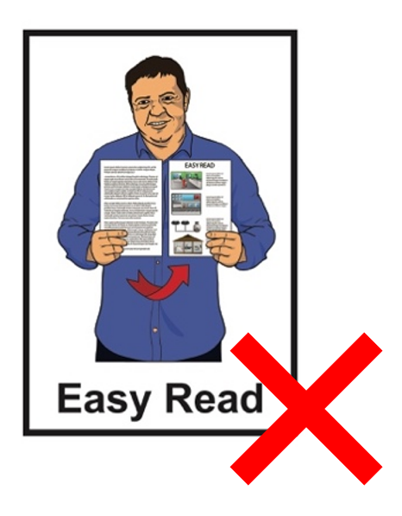
https://www.surveymonkey.com/r/KZ6WNYP

The survey is not in Easy Read.


You can ask someone to support you to do the survey like a:
whānau / family member
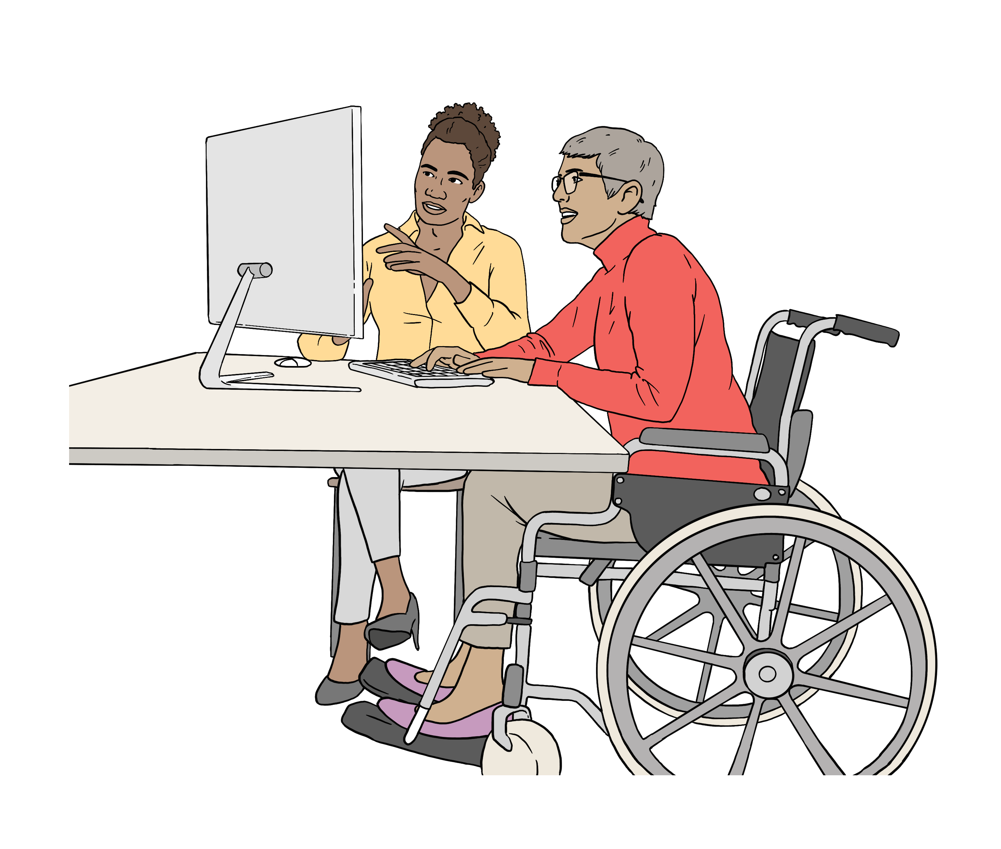
friend
support worker.
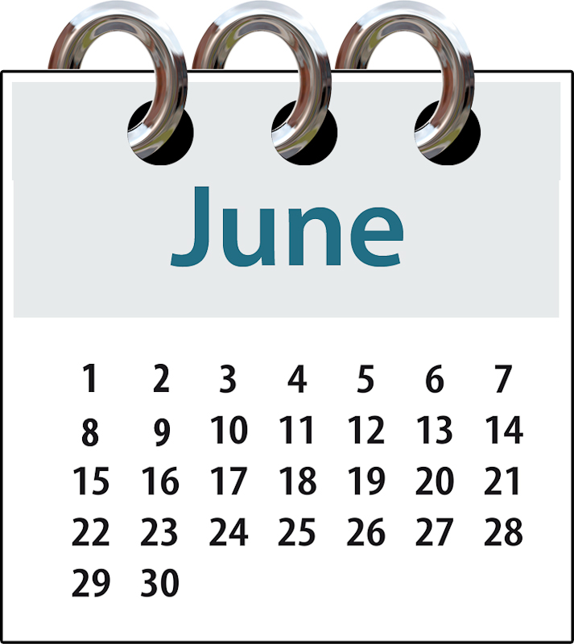
The survey closes on 18 June 2026.

Where to find more information

You can find more information about Finding Common Ground at:

www.dpa.org.nz/dpa-projects/
finding-common-ground/


You can sign up to get updates about this project at:

www.dpa.org.nz/dpa-projects/finding-common-ground/register-your-interest/

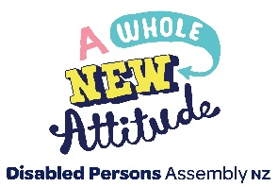
This information has been written by the Disabled Persons Assembly.

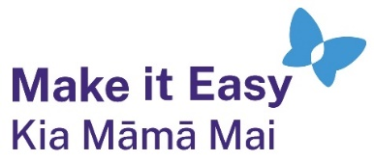
It has been translated into Easy Read by the Make it Easy Kia Māmā Mai service of People First New Zealand Ngā Tāngata Tuatahi.
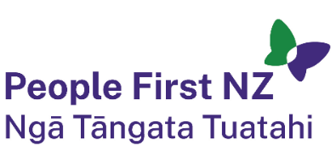
The ideas in this document are not the ideas of People First New Zealand Ngā Tāngata Tuatahi.

All images used in this Easy Read document are subject to copyright rules and cannot be used without permission.


Make it Easy uses images from:

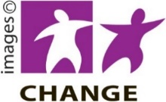
- Photosymbols

- Change Images

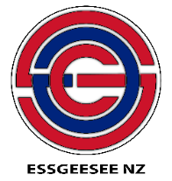
- Huriana Kopeke-Te Aho
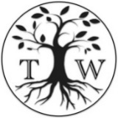
- SGC Image Works

- T Wood

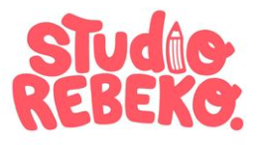
- Studio Rebeko

- Inga Kramer.

