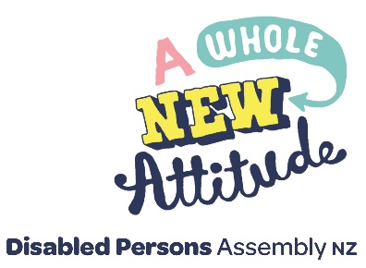

APPLICATION FOR ORGANISATIONAL MEMBERSHIP

Full name of the organisation

FOR: (Please tick to indicate which)

Organisation of
Disabled People

Membership
(full membership rights including voting)

Organisation for Disabled People Associate Membership (interested in activities of DPA, but non-voting)

PLEASE COMPLETE THE FOLLOWING AS APPROPRIATE

In support of our application the following information is provided

Contact person

Postal address

Phone number

Fax number

Email address

Total membership or
number of clients

Principle activities (in brief)

Other relevant information

As a member of DPA, respectfulness will be evident in all interactions associated with DPA. Business related to DPA will follow the DPA constitution, strategic plan and policies.

Privacy - None of this information gathered will be used in an identifiable form, or for any other purpose, without member’s permission. You are entitled to ask DPA (New Zealand) Inc for access to, and to correct, your personal information.

(please turn page)

MEMBERSHIP SUBSCRIPTIONS

For the one-year period of 1 July 20_ to 30 June 20_ or any part thereof

Organisations with under 25 members or clients

Organisations with 26 - 100 members or clients

Organisations with 101 - 200 members or clients

Organisations with 201 or more members or clients

Subscription we are paying

Donation to DPA

TOTAL

Region

GST No: 45 - 791 - 963

TAX INVOICE

Please accept this as the application from

$ 40.00

$ 80.00

$120.00

$150.00

$

$

$

Signature Date DD / MM / YYYY

Remittance can be made directly to our bank account. BNZ, Wellington, Account: 02-0500-0175915-00. Please include your organisations name as a reference.

Please send a completed copy of this Invoice to info@dpa.org.nz or to DPA National Office, PO Box 27-524, Marion Square, Wellington 6141.

ADDRESS PHONE

Level 4, +64 4 801 9100

175 Victoria St

PO Box 27524 WEBSITE
Wellington 6011, NZ dpa.org.nz

