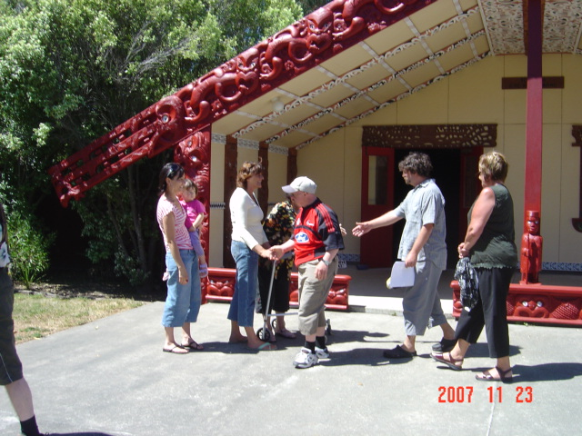

**He mihi**

Karanga karanga karanga ra,

Karangaha aa Matariki e tohungia ai te oranga hou,

Whakamaharatia tonu nei a raaatou ma kua riro ki te poo

moe mai i te rangimarie, noo reira, okioki atu

Ka rere tonu ngaa kupu whakamihi ki te hunga tautoko, kua tutukina teenei kaupapa i teenei wa,

Ma panga ma whero ka oti ai te mahi.

Noo reira, teenaa kautou teenaa kautou taatou katoa.

**Do disabled people get their human rights in new Zealand?**

In September 2008 New Zealand agreed with what was said in the **United Nations Convention on the Rights of Persons with Disabilities- the Disability Convention.**

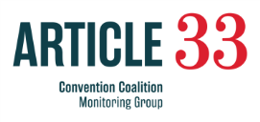**Article 33** of the Disability Convention is about countries making sure the rights in the Convention happen. Countries need to do this by putting the rights into action and by talking to disabled people to find out if they are getting their rights or not.

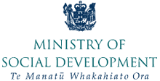To help do this the Ministry of Social Development gave money to the New Zealand Convention Coalition Monitoring Group to find out if disabled people in New Zealand get their rights.

The Convention Coalition is made up of Disabled Peoples’ Organisations.

The Convention Coalition works together to make disabled people lives better.

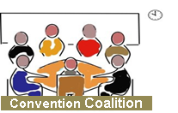**The Disabled People’s Organisations are:**

* Disabled Persons Assembly
* Association of Blind Citizens New Zealand
* Balance New Zealand
* 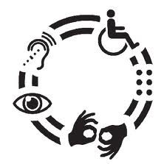Deaf Aotearoa NZ
* DeafBlind (NZ) Incorporated
* Ngā Hau e Whā
* Ngāti Kāpo o Aotearoa Inc
* People First New Zealand Inc. Nga Tangata Tuatahi

**The 2013 report is about the media**

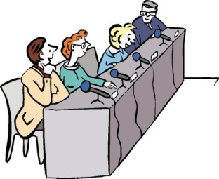

**Article 8**

**Article 8** of the Disability Convention talks about the way disabled people should be talked about in the media.



The **media** is:

* 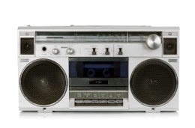the newspaper
* radio
* 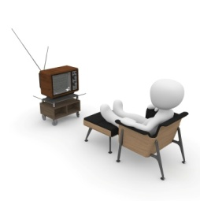the internet
* television
* social media like Facebook and Twitter.

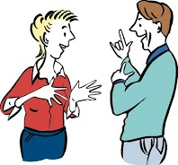This project was done to see how the **media**:

* talks about disabled people in news stories
* talks with disabled people about disability issues
* understands disabled people and their issues.

There were **3** parts to the project:

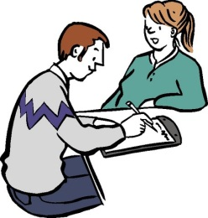

1. looking at what news stories have been in the media.

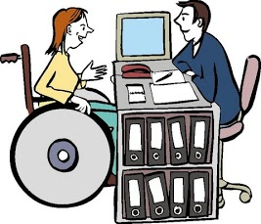

1. talking to people who work in the media

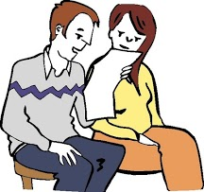

1. talking to disabled people



The project looked at all types of media for the whole of 2012.



The project looked at news stories and asked how the stories showed and talked about disabled people.

The project asked how the news stories were written. Were the news stories written as:

C:\Program Files (x86)\Microsoft Office\MEDIA\CAGCAT10\j0240719.wmf

* medical - showing disabled people as people who need fixing

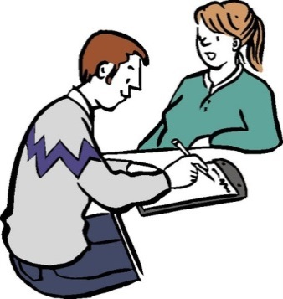

* charitable - showing disabled people as people to pity, feel sorry for and help out
* C:\Users\User\AppData\Local\Microsoft\Windows\Temporary Internet Files\Content.IE5\5XDE1JAS\MC910217210[1].wmfheroic or superhuman - showing disabled people as people who can overcome big challenges and are super-**human** for doing ordinary things

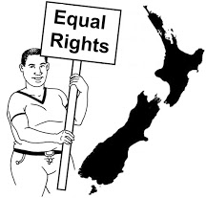

* rights based- showing disabled people as people who have the same rights as all other new Zealanders.

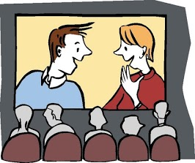The project looked news stories from:

* Radio
* TV
* Newspapers
* Broadcasting Standards Authority information.

**2** big news items that were also looked at.

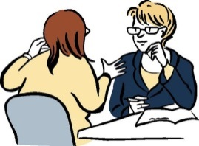

The project also:

* had face to face interviews

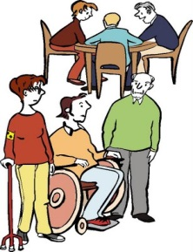

* met with groups of disabled people

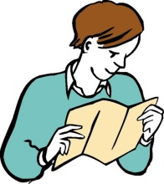

* did a survey

****The Convention Coalition works to make the lives of disabled people better.

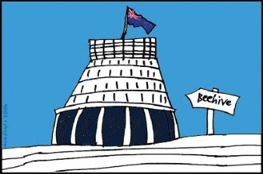The Convention Coalition did this project so that it could give good advice to the Government.

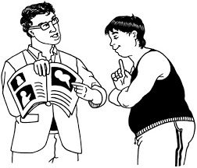The information from this project will help the Government to make the lives of disabled people better by:

* making new policies/ rules
* putting the new rules into action
* 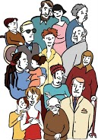learning how to work alongside disabled people.

**102** disabled people took part in the project.

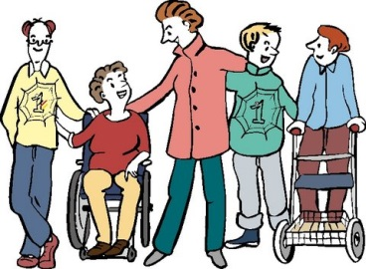

People with all sorts of disabilities were included in the project.

**The 2 big news items about disability issues**

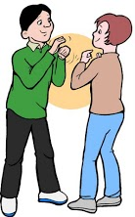The **2** big news stories about disability issues were:

1. Mojo Mathers problems with getting funding for her disability supports costs as a Member of Parliament

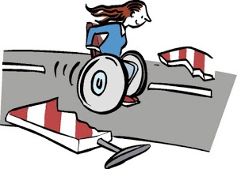

1. the 2012 Paralympics.

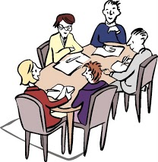**518** pieces of media were looked at from:

* 4 major daily newspapers
* Television
* radio.

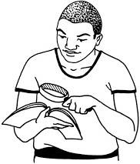Information was collected about:

* the type of story or programme
* where in the media the story was found
* who was speaking for disabled people
* if the issues important for disabled people were reported on.

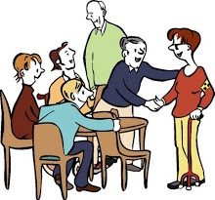

The information shows that:

* the media report in a way that shows **charity –**showing disabled people as people to pity, feel sorry for and help out
* 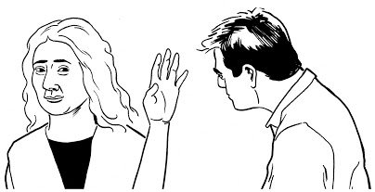disabled people’s voices are not included in reporting about disabled people and the issues disabled people face.
* there are almost no stories about disabled people who are Maori, Pasefika or other ethnic groups.

**Interviews with 12 people from the New Zealand media**



People from the media were from across New Zealand and were from:

* printed media: newspapers and magazines
* television



* radio.

The people from the media were asked:

* what they knew about disability issues
* 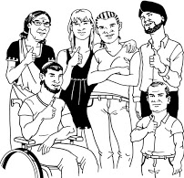how they chose the stories about disability issues
* if they talk to Disabled People’s Organisations about the current disability issues



* if they knew and understood the Disability Convention
* what they thought the media’s responsibilities were when they were reporting on disability related issues.

People from the media said:

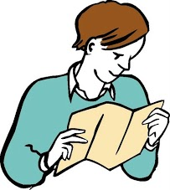

* there were no policies about reporting disability related issues
* 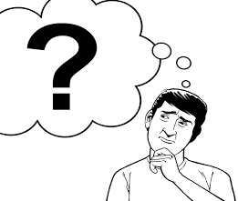there were guidelines about the language to use when talking about disabled people
* they were confused about how to approach reporting about disability issues

C:\Users\User\AppData\Local\Microsoft\Windows\Temporary Internet Files\Content.IE5\5XDE1JAS\MC910217210[1].wmf

* did not think their reporting styles made disabled people look like super heroes.

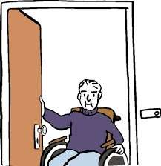The people from the media did not have a good understanding of:

* the Disability Convention
* 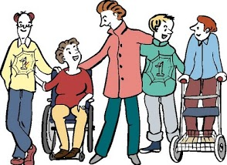who Disabled People’s Organisations are and what they do
* how disabled people are supported in New Zealand.

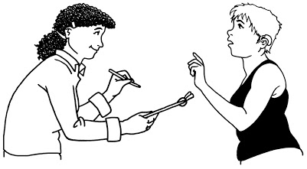The people from the media do not talk with Disabled People’s Organisations or disabled people about disability related stories.

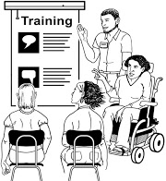

A few people from the media said they had done disability awareness training before starting out as a journalist.

**Feedback from 3 group meetings and the surveys**

Disabled people said the media:

* was a powerful tool for speaking up for disability issues and rights

**BUT**



* the media has very little disability awareness or understanding of the issues.

The media focused on:

* 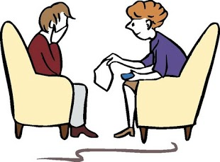negative stories
* charity stories- showing disabled people as people to pity, feel sorry for and help out
* C:\Users\User\AppData\Local\Microsoft\Windows\Temporary Internet Files\Content.IE5\5XDE1JAS\MC910217210[1].wmfheroic or superhuman stories- showing disabled people as people who can overcome big challenges and are super-human for doing ordinary things.

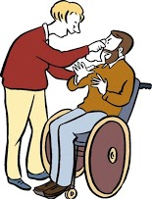People said that the how the media reported about disabled people often:

* used the wrong language
* gave out the wrong message.

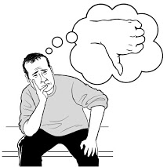 People who did the survey said:

* most people said the way the media had reported about disabled people had made them feel uncomfortable

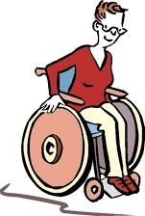

* over half of the people said they could remember some very good reporting about disabled people.



Most people thought there should be more disabled people in new stories that are not just about disability issues.

**Recommendations - the changes the Convention Coalition wants made**

1. 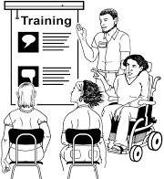All people who work in the media are trained by disabled people in:

* disability awareness
* disability rights.

It is important that the New Zealand Journalists Training Organisation supports the training.

1. Media organisations to:
   * 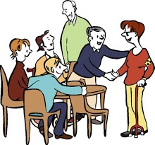have policies about how to talk about and report about disabled people and disability issues
   * work with Disabled People’s Organisations to write the policies
   * stop using negative language about disabled people.
2. 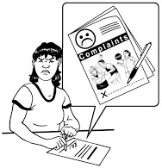Media organisations and government to work with disabled people to make it easier to make complaints about news stories.
3. Media organisations to have:
   * 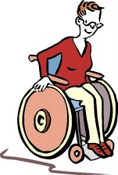more disabled people working for them
   * disabled people having roles to write and report on stories about disabled people
   * funding for disabled people who want to train and work in the media.
4. 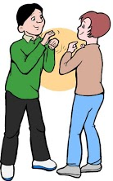Media organisations like the TV and radio to have disabled people as presenters.
5. 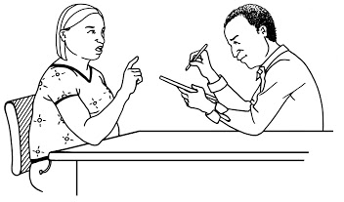Media to include disabled people in every day news stories.

News stories only talk about people’s disability if it is important to the story.

1. 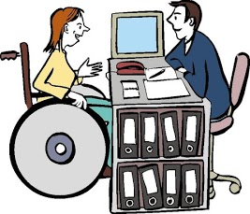Media organisations to work with Disabled People’s Organisations to:
   * get feedback about reporting of disability issues
   * have Disability Advisors just like some media organisations have Maori Advisors.
2. Disabled people be appointed to the boards that oversee media policies and regulations such as:

* Broadcasting Standards Authority
* New Zealand on Air
* New Zealand Press Council.

1. New Zealand on Air to:

* 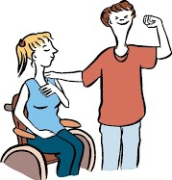keep funding disability programmes that are made and presented by disabled people
* have more funding available to make more disability programmes.

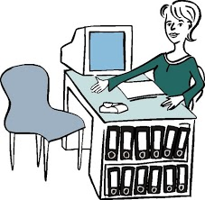

1. All the organisations involved in the funding and overseeing of the media to have disabled people employed in their organisations.
2. 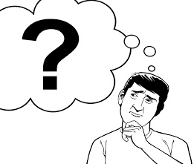Disability service providers need to be careful about how they are speaking about disabled people when talking to the media.

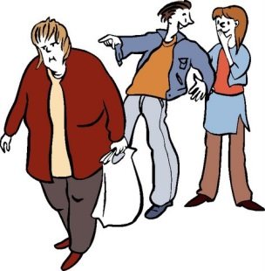

Disability service providers should not talk about disabled people:

1. 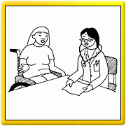in the medical model - as if they need fixing
2. 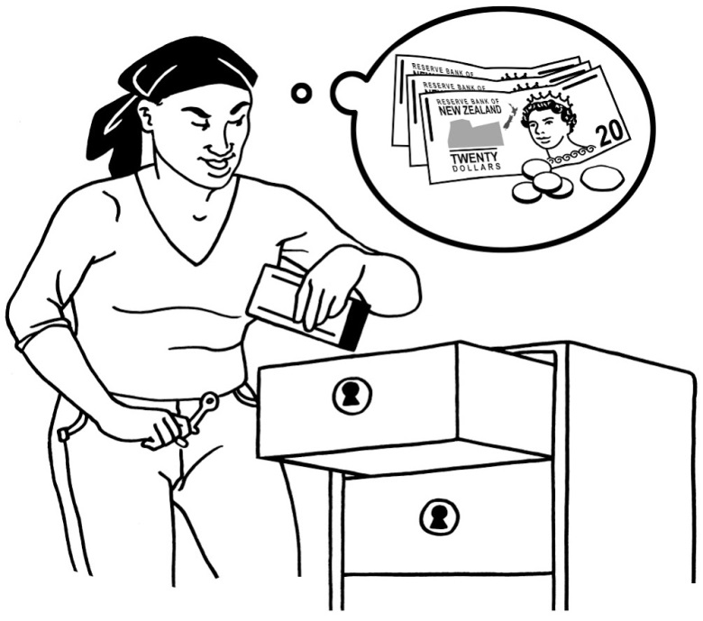in the charity model - as if they are people to pity, feel sorry for and help out
3. 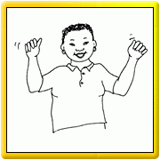as heroic or superhumans - as if they are people who can overcome big challenges and are superhuman for doing ordinary things.

This is especially important when asking people to give money to assist disabled people.

1. 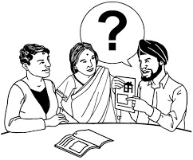Advisory groups and working groups are set up with Disabled People’s Organisations and media focused organisations to:

* advise on disability issues being dealt with in the media.

1. 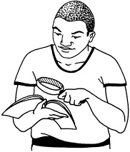Do a study looking at media attitudes towards disabled people and what changes are happening over time.

The study to:

be paid for by the government

be led by disabled people

include disabled people.

**Thank you**

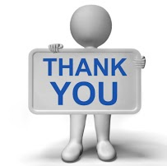Thank you to the members of the New Zealand Convention Coalition Monitoring Group:

* Rachel Noble (Chair)
* Beverley Grammar
* Kellye Bensley
* Mark Berry
* Merv Cox
* Warren Persson
* Leo McIntyre
* Magdel Hammond
* Nigel Ngahiwi
* Chrissie Cowan
* Graeme Parish
* Cindy Johns
* Mary Schnackenberg
* Rose Wilkinson
* Debs Craig
* Barbara Hart

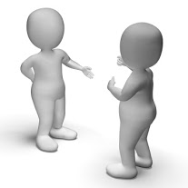Thanks also to The Project team:

* [](http://www.kozzi.com/stock-photo-24814881-thank-you-computer-key-as-online-thanks-message.html?tag=2160&tags=2160,65239,14448,2233)Pam MacNeill , Project Coordinator
* Chris Ford, Assistant Project Coordinator
* Alex Smith
* Peter Douglas
* Clive Lansink



Thanks to the 12 people from the media who were involved in the project.

Thanks also to:

* Paula Booth from DPA
* Professor Marcia Rioux, Disability Rights Promotion International
* Britta Offergeld, Adaptive Technology Consultant
* everyone who gave your thoughts.