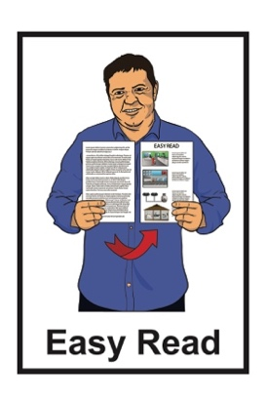

Finding a new Chief Executive
for Disabled Persons
Assembly NZ

Published: May 2023

About this document

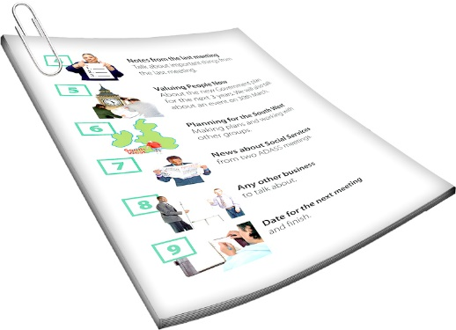
This Easy Read document is about finding a Chief Executive for Disabled Persons Assembly New Zealand.

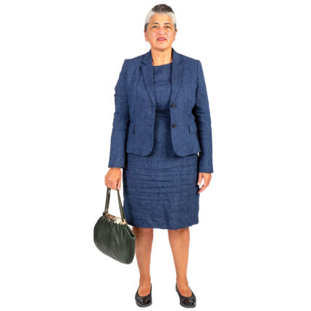
A Chief Executive is someone who is in charge of an organisation.

They are often called a CE.

Disabled Persons Assembly New Zealand is called DPA for short.

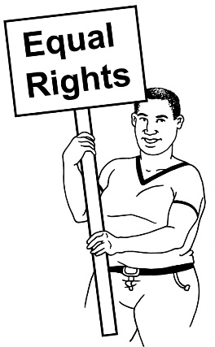
DPA works to make sure that disabled people have the same rights as everybody else.

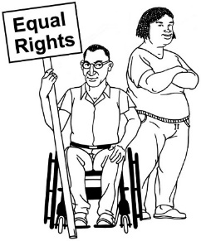
The work DPA does is based on:
- human rights
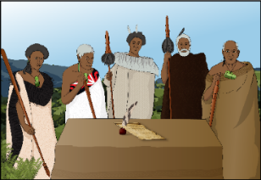
- Te Tiriti o Waitangi
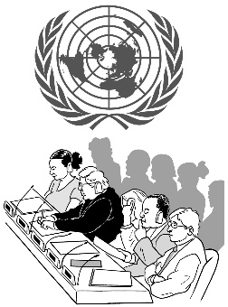
- the United Nations Convention on the Rights of Persons with Disabilities.

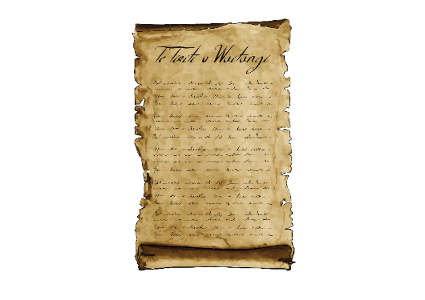
Te Tiriti o Waitangi / Treaty of Waitangi is an important agreement between Māori and the British Crown.

The United Nations Convention on the Rights of Persons with Disabilities is a law lots of countries have agreed to.

The United Nations Convention on the Rights of Persons with Disabilities is also called the UNCRPD.

About DPA

DPA is:
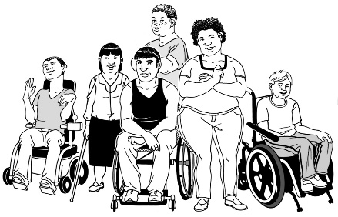
pan-impairment which means the work it does is for all disabled people
not for profit which means any money it makes goes into its work.

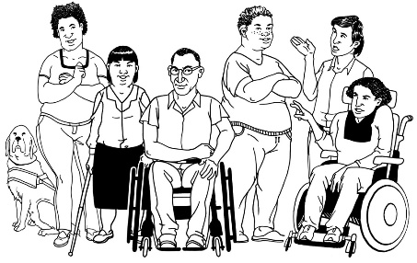
DPA is also a Disabled People’s Organisation which means it is run:

- by disabled people

- for disabled people.

DPA governance / staff members are mostly disabled people.
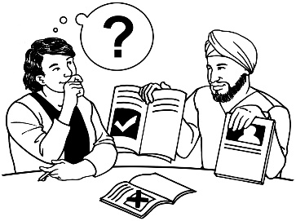
The work DPA does includes:
- giving information / advice
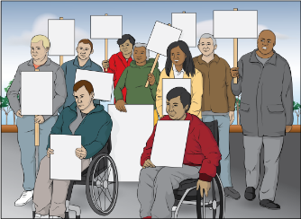
- speaking up as a community of disabled people
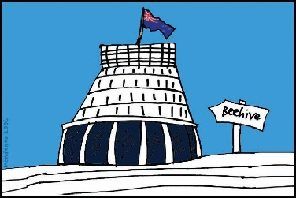
- looking at what the Government needs to do to make things better for disabled people
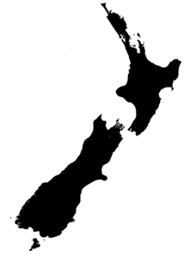
- speaking up about what disabled people think:
- in local areas
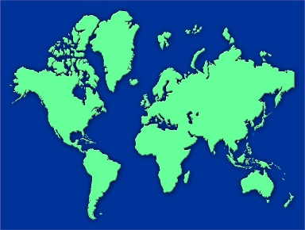
- across New Zealand
- around the world.

What does the CE do?

The CE leads the day to day running of DPA.

The CE makes sure DPA works towards the strategic plan.

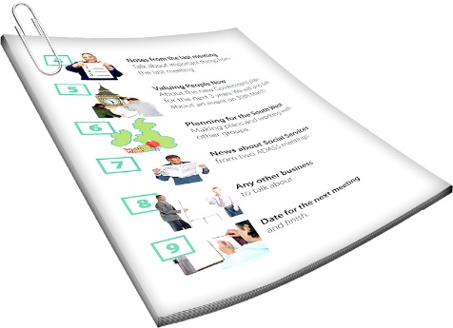
The strategic plan is a document that says:
what DPA wants to do
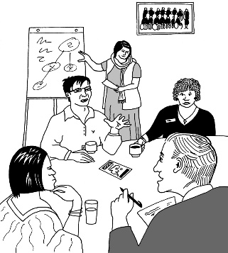
how they are going to do it.

The strategic plan is decided by the National Executive Committee.

The CE also manages how DPA uses money.
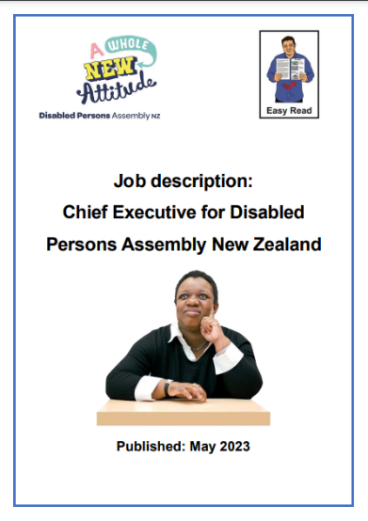
There is more information about what the CE does in an Easy Read document called:

Job description: Chief Executive for Disabled Persons Assembly New Zealand.

You can find this document:
as a pdf at:

www.dpa.org.nz/store/doc/DPA-CE-job-description---Easy-Read.pdf
as a Microsoft Word document at:

www.dpa.org.nz/store/doc/DPA-CE-job-description---Easy-Read.docx

What kind of person is DPA looking for?

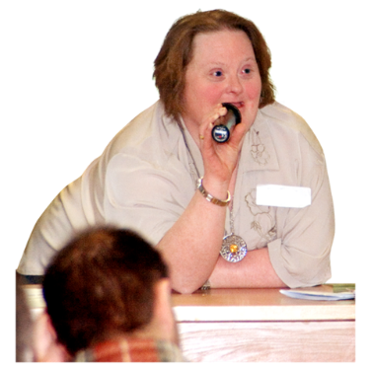
The right person for the job:
- will have leadership experience in disability rights
- can show they are committed to Te Tiriti o Waitangi
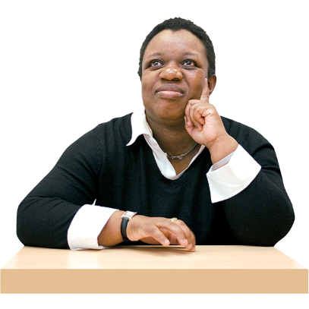
- will have been a manager before.

It would be good if the CE also has worked in one of these areas:
- management
- IT / computers
- finance
- HR / human resources management.
The CE will need to:
work to make sure that disabled people have the same rights as everybody else
makes sure all the every day work DPA does is done right
get to know all the people that are important for DPA to do its work
be the public face of the organisation.

Being the public face means they are the person from DPA who talks to the public.

This includes in the media like TV or newspapers.

DPA is a flexible workplace which means things can be changed to be a good fit for people.
It is flexible in:

- the time of day you do your work
- where you work as long as it is in New Zealand.

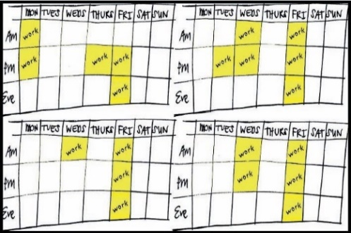
DPA are open to talking about how many hours the new CE will have to work.

It may be possible for 2 people to share the job.

DPA is committed to employing disabled people.

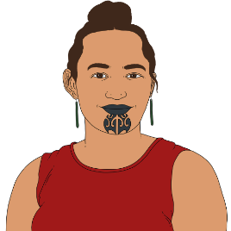
As well as disabled people DPA also encourages people to apply who are:
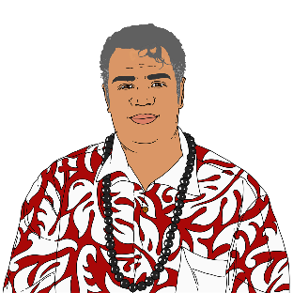
Māori
Pasifika
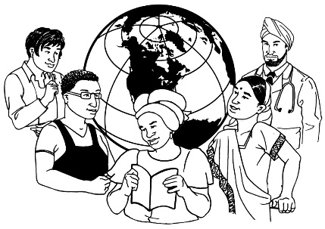
former refugees
migrants
from rainbow communities.

How to apply for the job

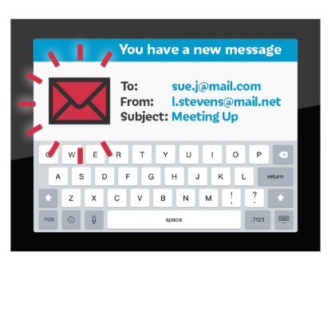
If you would like to apply for the job please email DPA a:

- cover letter

- CV.

Your cover letter should be addressed to:

Joanne Dacombe
National President

The email address to use is:

CErecruitment@dpa.org.nz

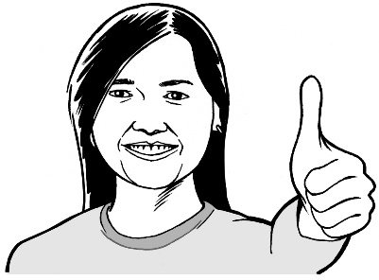
DPA want to make their application process accessible for everyone.

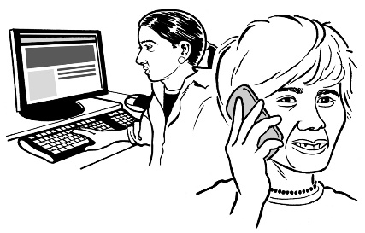
Please tell them if you need to apply in a different way.

You can also email them if you would like to find out more about the job.

The last date to apply is:
Monday 12 June 2023

This information has been written by Disabled Persons Assembly.

It has been translated into Easy Read by the Make it Easy Kia Māmā Mai service of People First New Zealand Ngā Tāngata Tuatahi.

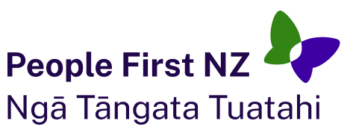
The ideas in this document are not the ideas of People First New Zealand Ngā Tāngata Tuatahi.

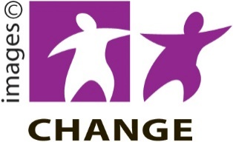
Make it Easy uses images from:

- Changepeople.org

- Photosymbols.com

- SGC Image Works

- Huriana Kopeke-Te Aho.
All images used in this Easy Read document are subject to copyright rules and cannot be used without permission.

