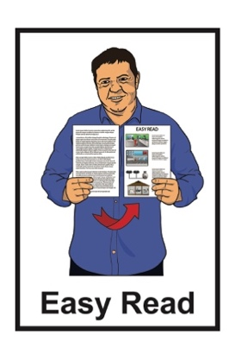

Job description:

Chief Executive for Disabled Persons Assembly New Zealand

Published: May 2023

About this document

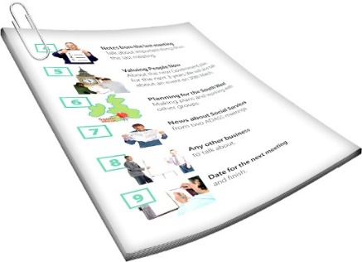
This Easy Read document is the job description for the Chief Executive of Disabled Persons Assembly New Zealand.

A job description says:
what a person does in their job
what skills a person needs to do their job well.

A Chief Executive is someone who is in charge of an organisation.

They are often called a CE.

Disabled Persons Assembly New Zealand is called DPA for short.

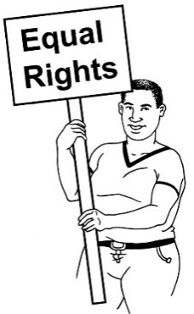
DPA works to make sure that disabled people have the same rights as everybody else.

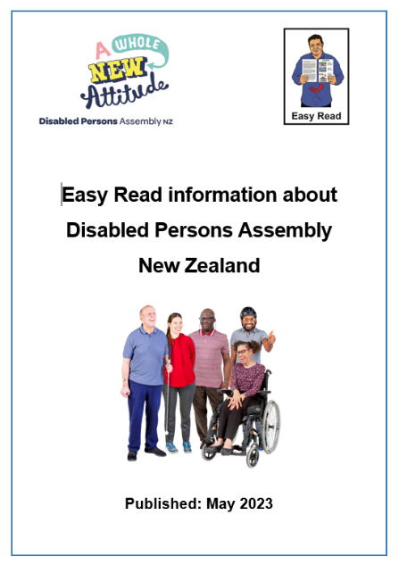
You can find more Easy Read information about DPA in a document called:

Easy Read information about the Disabled Persons Assembly of New Zealand

You can find this document on the DPA website:

www.infoexchange.nz/about-dpa/

What the CE of DPA does

The CE for DPA reports to the DPA National Executive Committee through the National President.

The DPA National Executive Committee makes the decisions about:
- what DPA wants to do
- how they are going to do it.

They are also called the NEC.

The CE leads the day to day running of DPA.

The CE makes sure DPA works towards the strategic plan.
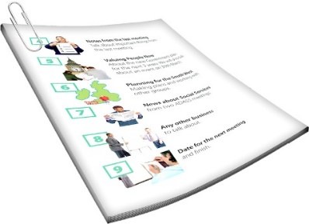

The strategic plan is a document that says:
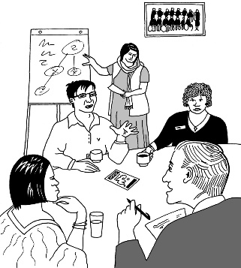
what DPA wants to do
how they are going to do it.

The strategic plan is decided by the National Executive Committee.

The CE also manages how DPA uses money.

The CE can work from anywhere in New Zealand.

What the CE should know

This part of the job description is about what the CE needs to know about to do their job.

The CE should know:
about the disabled community in:
- different parts of New Zealand
- the whole of New Zealand
- a little about the disabled community in the world
about what guides DPA work.

The CE should also know about the laws for:
employment / jobs
health and safety
incorporated societies
charities.

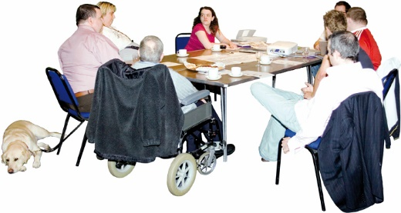
Incorporated societies are a kind of organisation.

Charities are a different kind of organisation.

There are different rules for different kinds of organisation.

The CE should also:
have experience as a leader in disability rights
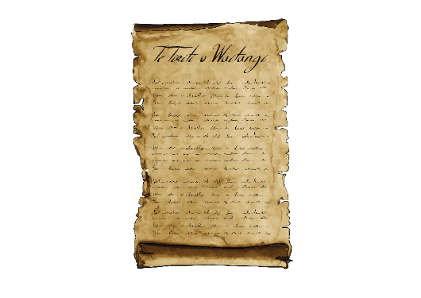
be committed to Te Tiriti o Waitangi / the Treaty of Waitangi.

Te Tiriti o Waitangi / Treaty of Waitangi is an important agreement between Māori and the British Crown.

It would be good if the CE also has worked in 1 of these areas:
management
IT / computers
finance / money
HR / human resources management.

What the CE needs to do

This part of the job description is about the important things the CE will need to do.

Looking at these things will show how well they are doing in their job.

We have put these things into
8 groups.

Strategy

Strategy means working to a plan that:
is for a long time
can change when it needs to.

The CE will:
lead what happens in the organisation to make the strategic plan happen
support the work of the NEC
make sure there is good communication between:
- NEC
- DPA members
- people who work for DPA.
The CE will also:
create programmes / projects that support things changing so things are fairer for disabled people
makes sure those programmes / projects happen

The CE will also look at how things are going at DPA so they can find ways of doing things that:
fit with the things DPA has decided to do first
can keep being paid for.

Relationships

Relationships mean connections between:
people
organisations.

The CE should:
be very good at working with people
be able to talk to lots of different kinds of people in a way that works for them.

The CE will need to:
make connections between:
  - tāngata whaikaha Māori / Māori disabled people
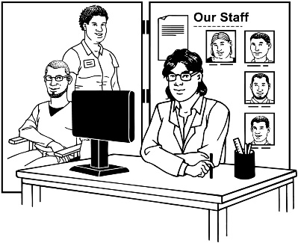
  - disabled people
- people who work in the disability sector
- other people who support disability rights
make more connections with those groups so lots of people are speaking up together on disability issues.

The CE will work on relationships that support the work of DPA:
in different places in New Zealand
in the whole of New Zealand
in other countries.

Operational
Operational means keeping DPA running well day to day.

The CE will:
make sure the ways DPA does things are working well
be in charge of staff employment relationships.
The CE will also make sure the workplace is:
supportive
accessible
a place people can work together well.

Financial

Financial means to do with money.

The CE will make sure there is enough money for DPA to do its work:
now
in the future / years to come.
The CE also looks after the annual budget.

The annual budget is a plan for what money DPA will:
get in the next year
spend in the next year.

The CE will:
plan the budget every year
make sure the budget includes everything DPA needs
ask the NEC to agree to the budget.

Leadership
The Chief Executive will:
show people what disabled leadership is like
support disabled people who are becoming leaders
speak up for DPA
make sure the DPA speaks up in the way the members want
understand:
- what they do well
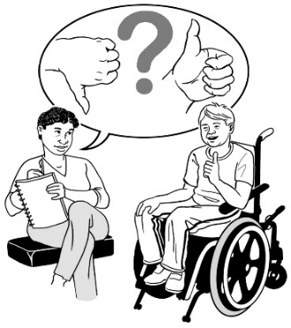
- what they need to do better
ask people for their thoughts on how they are doing.

Advocacy

The CE should speak up about the rights of disabled people by:
making plans to change what is not working for disabled people in their communities
using the skills they have to work to make change
knowing when to:
- talk about change
- talk to the media like TV or newspapers.

Monitoring

Monitoring means watching how things are going.

The CE will:
know about the laws/law changes that are important to:
- tāngata whaikaha Māori
- disabled people
- whānau

- understand that for disabled people to have better lives it is important to:
  - find out information

  - analyse that information which means finding out what it means.
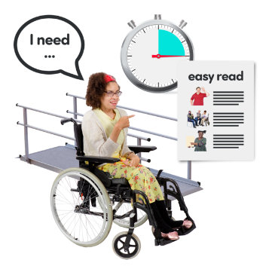
The CE should also make sure DPA works to remove barriers to disabled people having the same rights as everybody else.
Barriers are things that make it harder for disabled people to have a fair chance.

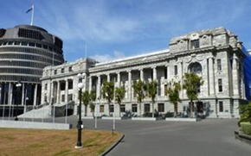
The barriers need to be understood by:
government organisations
businesses
the public.

The CE also makes sure DPA works with the DPO Coalition to support government agencies to make the things on the Disability Action Plan happen.

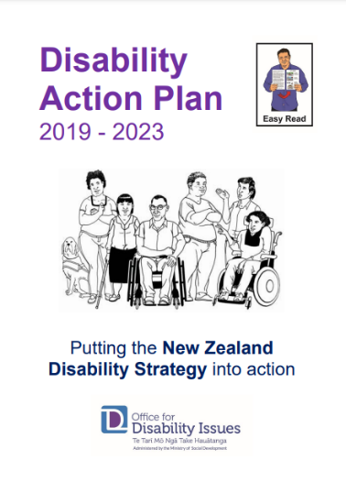
The Disability Action Plan is a plan for the work the government is going to do about disability.

You can find an Easy Read translation of the Disability Action Plan on the Office for Disability Issues website at:

https://tinyurl.com/wtymx3rb

Information and advice

The Chief Executive should make sure information is communicated between:
disabled people
government.

Where to find more information

You can find more information about DPA on their website at:

www.dpa.org.nz

You can also contact DPA:
by phone on:
04 801 9100
by email at:
info@dpa.org.nz

This information has been written by Disabled Persons Assembly New Zealand.

It has been translated into Easy Read by the Make it Easy Kia Māmā Mai service of People First New Zealand Ngā Tāngata Tuatahi.

The ideas in this document are not the ideas of People First New Zealand Ngā Tāngata Tuatahi.

Make it Easy uses images from:

- Changepeople.org

- Photosymbols.com

- SGC Image Works

- Huriana Kopeke-Te Aho.
All images used in this Easy Read document are subject to copyright rules and cannot be used without permission.

