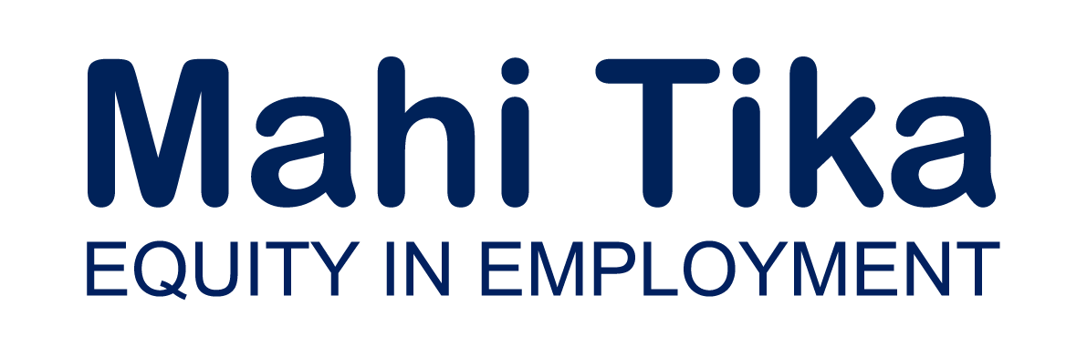

Resources for Employers

Disabled people are an underutilised workforce
24% of New Zealanders are identified as disabled (Statistics NZ, 2013) but they are underrepresented in employment. The most recent Labour market statistics for disability data revealed that only 41.5% of working-age disabled people were employed in the June 2022 quarter compared with 80.1% of non-disabled (Statistics NZ, 2022). The Working Matters Action Plan to ensure disabled people and people with health conditions have an equal opportunity to access employment (Ministry of Social Development, 2020) shows that 74% of those not working would like to be if a job were available. However, it’s often systemic barriers that prevent disabled people from gaining or sustaining employment (Disabled Persons Assembly NZ, 2023), along with recruitment policies and practices that are not inclusive. Local research shows that employers acknowledge the low employment of disabled people is an issue and that disabled people deserve a fair go (Woodley, Metzger & Dylan, 2012).

There is no Diversity, Equity and Inclusion without disability
Many workplaces have Diversity, Equity and Inclusion (DE&I) programmes to ensure employment opportunities for marginalised communities. However, disability doesn’t often appear very high on the priorities list, despite disabled people often also being part of other marginalised groups, such as Māori, Pasifika, women, Rainbow, ex-refugee, etc. By developing recruitment policies and practices to be inclusive of disabled people, your organisation will also be engaging with other marginalised communities.

What is the definition of disabled?
The United Nations Convention on the Rights of Persons with Disabilities defines disabled people as “those who have long-term physical, mental, intellectual or sensory impairments which in interaction with various barriers may hinder their full and effective participation in society on an equal basis with others”.

What resources are there for employers?
For a start, employers can look to the Ministry of Social Development’s Lead Toolkit, which is currently in the process of being updated. It currently includes resources such as:
- Lead Toolkit A guide for employing disabled people.
- Accessible meetings and events A guide for planning accessible meetings and events.
- Checklist A checklist for assessing an organisation's ability to attract and retain disabled people.
- Interviewing disabled people A guide to help employers prepare for interviews
- with disabled people.
- Practical tips for people managers A guide to working effectively with disabled employees.
- Practical steps for managers Reasonable accommodation.
- Reasonable accommodation A guide to developing policies and procedures to assist disabled people through reasonable accommodation (workplace adjustments).
- Summer internships A guide to help you with hiring disabled people for summer internship roles.
- Retaining existing employees Advice for Line Managers.
Reasonable accommodations, also known as workplace adjustments, are an important part of ensuring an inclusive workplace. The Human Rights Commission, The Office of the Ombudsman, and the DPO Coalition (which includes Disabled Persons Assembly NZ) recently released an updated guide on reasonable accommodations:
- Removing barriers: A guide for reasonable accommodation of disabled people in Aotearoa.
Employment.govt.nz also provides information and resources for employers around the employment of disabled people, including:
- Employment for disabled people Information to help remove barriers to employment for disabled people.
- Disability definitions and etiquette The term 'disability' covers a variety of situations.
- The benefits of being a disability confident organisation Disabled people work in all sorts of roles and have a range of skills, talents and abilities. Businesses employ disabled people because it makes good business sense.
- Planning to become a disability confident organisation A disability confident organisation understands disability and identifies ways to remove barriers to employment and promotion.
- Reasonable accommodation Making reasonable accommodation helps organisations to confidently recruit, retain and support disabled people.
- Communications support Information to help organisations become more accessible and communicate effectively with disabled people.
- Hiring disabled people Information to help employers hiring staff not miss out on the potential offered by disabled people.
- Keeping disabled employees Actively supporting and keeping disabled employees has benefits for your organisation.
- Financial help and wages Financial help and wage information for disabled jobseekers and employees, and their employers.
- Disability information and resources for employers Resource material designed specifically to assist employers is freely available.
- Resources and government support for disabled employees and jobseekers Resources and services designed specifically to assist disabled employees and jobseekers.
Other useful resources include:
- Making the recruitment process inclusive A factsheet providing practical advice to Managers and Human Resource staff to ensure their recruitment process is inclusive.
- The Price of Exclusion The economic consequences of excluding disabled people from the world of work.
- EmployAbility A resource guide on disability for employers in Asia and the Pacific.
- Employer attitudes toward employing disabled people Research on New Zealand employers’ attitudes towards employing disabled people.
- Benefits of creating inclusive workplaces Research on the importance of social inclusion and natural supports for disabled staff.

Disclosure
Disclosure is a complex topic. Disabled people are often discriminated against because of their impairment or health condition so may not want to disclose their status. However, applicants are frequently asked in the recruitment process whether they have a disability or health condition that could affect their ability to do the job advertised. The key words here are ‘affect their ability’. If the right accommodations are put in place, there is usually no reason why a person would not be able to fulfil the job requirements. Therefore, it is important that employers implement policies and practices that ensure a safe, inclusive recruitment process where disabled people can choose to, or not to, disclose without fear of discrimination and still be able gain equitable access to their workplace.

Employer networks
New Zealand Disability Employers’ Network (NZDEN) is a network of NZ employers committed to improving their disability inclusion and accessibility practices.

Employee networks
Organisations can also support employee-led networks to help employees connect, share ideas and support each other. These networks are well-supported in the public service. The Employee Led Networks Te Puna Huihuinga Kaimahi provides advice to organisation-level network leads and people leaders as well as providing useful resources on setting up employee-led networks:
- How can people leaders support employee-led networks? A quick guide for supporting employee-led networks.
- Guidelines for Employee Networks The New South Wales Public Service Commission offers a helpful guide and a step-by-step process for setting up and running an employee network.

Diversity, Equity and Inclusion Conferences
Conferences that focus on disability inclusion are a valuable way of connecting with disabled people and other organisations committed to inclusive recruitment.
- Disability Inclusive Pathways Conference An NZDEN opportunity to connect with other organisations committed to advancing disability and inclusion outcomes in the workplace.
- Workforce Inclusion and Diversity Conference A Diversity Works NZ event to help you to implement best practice diversity and inclusion strategies at your organisation.

Disabled Persons Assembly NZ (DPA)
As an organisation, DPA drives systemic change for the equity of disabled people. We do this through:
- Leadership: reflecting the collective voice of disabled people, locally, nationally and internationally.
- Information and advice: informing and advising on policies impacting on the lives of disabled people.
- Advocacy: supporting disabled people to have a voice, including a collective voice, in society.
- Monitoring: monitoring and giving feedback on existing laws, policies and practices about and relevant to disabled people.

DPA working with employers
DPA can discuss options for tailored consultation, advice and workshops with organisations looking to develop more inclusive employment policies and practices.
You can also talk to us about advertising roles in your organisation to our community networks. Job advertisements are shared through our Information Exchange newsletter and website www.InfoExchange.nz.
If you are interested in discussing further, you can contact us on info@dpa.org.nz

