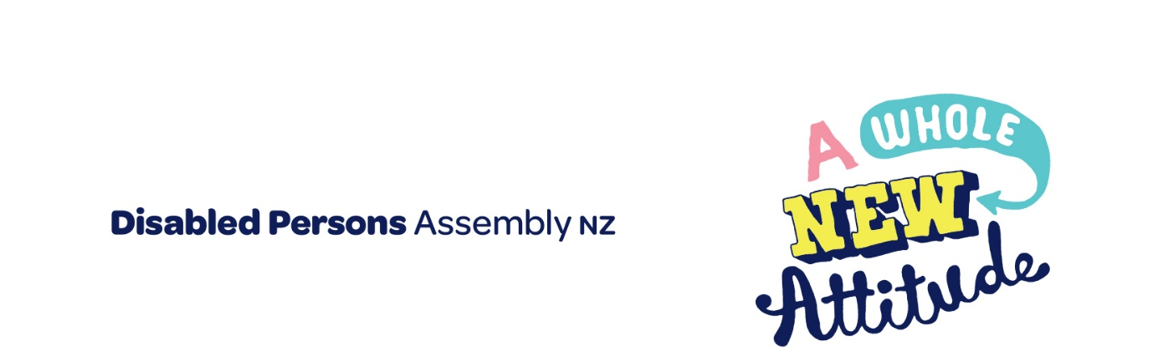

October 2022

To
Please find attached DPA’s submission on the Accessibility for New Zealanders Bill

For any further inquiries, please contact:
Prudence Walker
Chief Executive
021 546 006
policy@dpa.org.nz

Introducing Disabled Persons Assembly NZ
We work on systemic change for the equity of disabled people
Disabled Persons Assembly NZ (DPA) is a not-for-profit pan-impairment Disabled People’s Organisation run by and for disabled people.
We recognise:
- Māori as Tangata Whenua and Te Tiriti o Waitangi as the founding document of Aotearoa New Zealand;
- disabled people as experts on their own lives;
- the Social Model of Disability as the guiding principle for interpreting disability and impairment;
- the United Nations Convention on the Rights of Persons with Disabilities as the basis for disabled people’s relationship with the State;
- the New Zealand Disability Strategy as Government agencies’ guide on disability issues; and
- the Enabling Good Lives Principles, Whāia Te Ao Mārama: Māori Disability Action Plan, and Faiva Ora: National Pasifika Disability Disability Plan as avenues to disabled people gaining greater choice and control over their lives and supports.
We drive systemic change through:
- Leadership: reflecting the collective voice of disabled people, locally, nationally and internationally.
- Information and advice: informing and advising on policies impacting on the lives of disabled people.
- Advocacy: supporting disabled people to have a voice, including a collective voice, in society.
- Monitoring: monitoring and giving feedback on existing laws, policies and practices about and relevant to disabled people.

The Submission
There are two key documents for disabled people relevant to DPA’s submission which we outline below.

United Nations Convention on the Rights of Persons with Disabilities
DPA was influential in creating the United Nations Convention on the Rights of Persons with Disabilities (UNCRPD), a foundational document for disabled people which New Zealand has signed and ratified, confirming that disabled people must have the same human rights as everyone else.
All state bodies in New Zealand, including local and regional government, have a responsibility to uphold the principles and articles of this convention.
As a minimum any accessibility bill must meet the commitments in the UNCRPD.
There are a number of UNCRPD articles pertinent to this submission, but the most relevant one for this bill is:

Article 9 – Accessibility
Clauses 1 and 2 (a) and (b) are particularly relevant for this submission.
Clause 1 makes it clear that the State is expected to take measures to ensure accessibility of specific domains for disabled people: including the built environment, transport, public servies and information and communications.
Clause 2 (a) makes it clear that the state has a responsibility to set minimum standards for these domains and clause 2 (b) that the state has a responsibility to require private entities offering services to the public to be accessible.
Clause 1. To enable persons with disabilities to live independently and participate fully in all aspects of life, States Parties shall take appropriate measures to ensure to persons with disabilities access, on an equal basis with others, to the physical environment, to transportation, to information and communications, including information and communications technologies and systems, and to other facilities and services open or provided to the public, both in urban and in rural areas. These measures, which shall include the identification and elimination of obstacles and barriers to accessibility, shall apply to, inter alia:
a) Buildings, roads, transportation and other indoor and outdoor facilities, including schools, housing, medical facilities and workplaces;
b) Information, communications and other services, including electronic services and emergency services.
Clause 2. States Parties shall also take appropriate measures:
a) To develop, promulgate and monitor the implementation of minimum standards and guidelines for the accessibility of facilities and services open or provided to the public;
b) To ensure that private entities that offer facilities and services which are open or provided to the public take into account all aspects of accessibility for persons with disabilities;

New Zealand Disability Strategy 2016-2026
Since ratifying the UNCRPD, the New Zealand Government has established a Disability Strategy to guide the work of government agencies on disability issues. The vision is that New Zealand be a non-disabling society, where disabled people have equal opportunity to achieve their goals and aspirations, and that all of New Zealand works together to make this happen.
It identifies eight outcome areas contributing to achieving this vision, including:

Outcome 5 - Accessibility

“We access all places, services and information with ease and dignity”

Accessibility for New Zealanders Bill
DPA believes that the bill is structurally flawed in its design. It fails to meet the minimum commitments around progressing accessibility that government has agreed to in article 9 of the UNCRPD. Most of what is in the bill could be achieved without legislation and it contains little of meaningful substance.
DPA does not support the bill in its current form.
Disabled people face accessibility barriers in every aspect of our lives. Inaccessible buildings, information, services, and transport impact on our rights to access employment, housing and on our health and wellbeing.
Our members have told us that they believe that this bill will at best make little difference to disabled people’s lives. At worse there is concern it will actually slow down progress on accessibility and may well create a bottle neck for work on accessibility across government if it sets an expectation that all accessibility workstreams will need to go through the accessibility committee before being initiated or actioned.
DPA notes that over the years there have been numerous reports which make specific recommendations to improve accessibility ranging from transport, buildings and captioning , yet despite this, few of these recommendations have ever been actioned in full by government.
There is a real risk that a bill that only sets up an advisory committee will see yet again recommendations to improve accessibility that do not get actioned.
The issue here is not lack of knowledge of what is needed to change to improve accessibility. These are actually well canvassed.
Broadly speaking known accessibility issues are either that
- An accessibility standard exists but it is outdated or interpreted and/or enforced incorrectly (for example, standard 4121) or
- An accessibility standard exists but private entities offering public services are not required to apply it and/or there is no enforcement agency with powers to enforce it (for example, Web accessibility standard) or
- No accessibility standard or responsible agency exists (for example communications)
The bill does not address any of these systemic issues. DPA is of the view that we do not need yet another report or committee recommending various actions. We need actual action and these need to span from setting, monitoring, reviewing and enforcing minimum standards of accessibility across a range of domains.
As highlighted in the previous section, article 9 of the UNCRPD makes it clear that government has a responsibility to set minimum standards for accessibility for facilities and services to the public and that these must apply across government, including local government and private entities offering public services.
An advisory committee situated within a ministry with no powers beyond requesting information is simply not the right structure to progress this work.
DPA would like the select committee to note that in September 2022 the UN committee also commented on the failings of this bill as follows.
(d) Reports from organisations of persons with disabilities that the Accessibility for New Zealanders Bill, currently before Parliament does not contain enforcement mechanisms, may not cover private entities or local government, lacks standard-setting and decision-making bodies, and lacks obligations to make tangible changes within fixed time frames.
The recommendation in relation to this by the UN was:
(d) Establish a co-design and co-production process with organisations of persons with disabilities to address concerns about the Accessibility for New Zealanders Bill, following release of the Select Committee’s report.
DPA strongly agrees with these comments from the UN, and we ask for the select committee to recommend that the bill be redrafted via a genuine co-design and co-production process with disabled people, tangata whaikaha Māori, DPO’s and the wider disabled community.
As a minimum, DPA considers that any accessibility bill must provide for an independent crown entity that has standard setting, decision making, monitoring and enforcement powers, including the ability to set minimum standards for accessibility that apply across central government, local government and private entities offering public services.
Furthermore, DPA feels that it would be wise for such an entity to be separate from the new ministry Whaikaha. This is because Whaikaha has lead responsibility for delivery of disability support services which creates a potential conflict where they become responsible for setting the standards for the services they are delivering.

DPA’s Recommendations
DPA recommends that :
- The Accessibility for New Zealanders bill be redrafted via a genuine co-design and co-production process with disabled people, tangata whaikaha Māori, DPO’s and the wider disabled community.
- The bill provides for an independent crown entity that has standard setting, decision making, monitoring and enforcement powers, including the ability to set minimum standards for accessibility that apply across central government, local government and private entities offering public services.
- Any accessibility entity be separate from the new ministry Whaikaha to avoid a conflict of interest as a major service provider for disabled people.

United Nations. (2006). United Nations Convention on the Rights of People with Disabilities. Retrieved from: https://www.un.org/disabilities/documents/convention/convoptprot-e.pdf
Article 9 – Accessibility | United Nations Enable
Office for Disability Issues. (2016). New Zealand Disability Strategy. Retrieved from: https://www.odi.govt.nz/nz-disability-strategy/
The Accesibility Journey: Report of the Inquiry into Accessible Public Land Transport Accessible Public Land Transport » The Hub (swa.govt.nz)
Human Rights Commission :: Better Design and Buildings for Everyone (hrc.co.nz)
Inquiry into captioning in New Zealand - New Zealand Parliament (www.parliament.nz)

