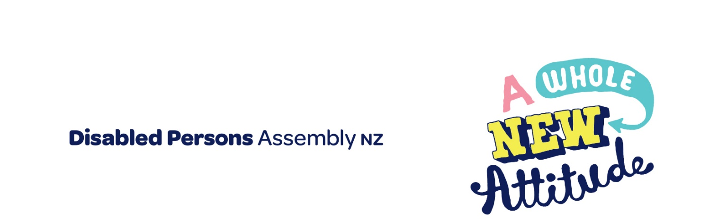
Disability and Poverty

This paper is a supplementary submission from Disabled Person’s Assembly. It provides specific information in response to the question asked by Minister Greg O’Connor relating to the connection between disability and poverty at the in-person submission on the Budget Policy Statement on 12 February 2020.

Contact:
Prudence Walker
Chief Executive,
Disabled Person’s Assembly
policy@dpa.org.nz
021 546 006

The connection between disability and poverty
The relationship between disability and socioeconomic status is a complex one, and is highly dependent upon the nature of the disability and the age that disability was acquired (Child Poverty Action Group, 2015).
In brief:
- The 2013 Disability Survey notes that approximately 11% of children aged 0-14 have a disability (Statistics New Zealand, 2013).
- The 2013 census notes that 24% of the population identify as disabled (Statistics NZ, 2013).
- Disabled people aged under 65 are almost 2.5 times more likely to report not having enough income than non-disabled people under 65 (CCS Disability Action, 2019). Disabled people over 65 are 1.5 times more likely to report not having enough (CCS Disability Action, 2019). This disparity is largely because many disabled people over 65 have recently acquired disabilities and have thus not needed to face disability-related barriers for much of their live, and have had more of an opportunity to build financial assets.
- The table below is a screenshot taken from the CCS Disability Action (2019) report (p. 27), which demonstrates the data on this point:

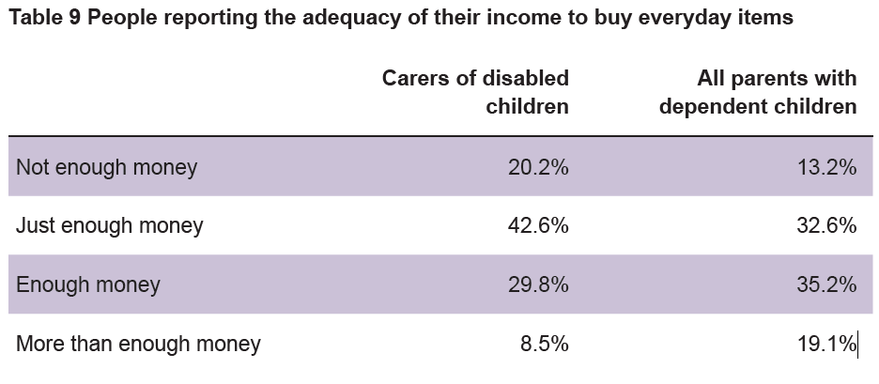

- Disabled children are significantly more likely more likely to live in low-income households. The 2013 Disability Survey shows that 15% of disabled children live in households with incomes under $30,000, compared with 10% of non-disabled children (Statistics New Zealand, 2013).
- CCS Disability Action (2019) note that “households with disabled children are between 1.4 and 1.6 times more likely to be below all three poverty thresholds than households that only had non-disabled children” (p. 24)
- The table below is a screenshot taken from the CCS Disability Action (2019) report (p. 25), which demonstrates the data on this point:

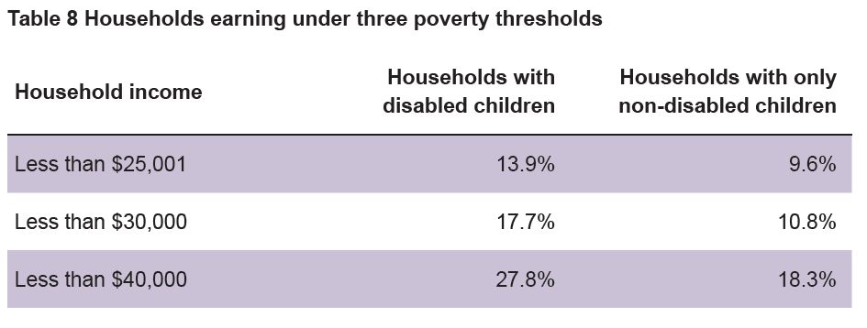
- The Expert Advisory Group on Solutions to Child Poverty (2012) notes that “international data on the intersection of disability and child poverty combined with New Zealand data about the socio-economic status of people with disabilities provides sufficient evidence to show that people with disabilities are disadvantaged in terms of income, educational and employment opportunities, health and wellbeing, and full participation in community compared with the general population” (p. 2).

The extra costs of disability
There are many costs associated with having a disability. Routine activities for the general population can become costly, difficult and often completely inaccessible when you or your child has a disability. This includes:
- Raising disabled children. The Expert Advisory Group on Solutions to Child Poverty (2012) cites international research which shows that “the cost of raising a child with a disability can be up to three times that of raising a non-disabled child” (Council for Disabled Children, 2007, cited in Expert Advisory Group on Solutions to Child Poverty, 2012, p. 10).

- Transportation. Many people are reliant on cars, taxis and busses where other people would be able to walk or bike. Transportation can be expensive, particularly taxi’s (subsidised taxi’s are still very expensive), and public transportation is not always accessible for disabled people (particularly outside of major urban centres).

- Housing. There is a severe lack of accessible housing in NZ, and families and individual’s often need to spend their own money to modify houses. Many disabled people live in houses which are not suited to their needs; the Expert Advisory Group on Solutions to Child Poverty (2012) notes that “people with disabilities who are also low income or living on benefits all too often live in housing that is not sufficiently accessible, is unsafe, cold and damp” (p. 10).

There are also and there are long wait-lists for housing modifications, with restrictions on what modifications are allowed (for instance, if you live with other people then kitchen modifications are considered unnecessary, requiring your family/flatmates to do all the cooking for you), and how many times you are able to access them (usually once per lifetime), regardless of whether you are forced to move or not. The Expert Advisory Group on Solutions to Child Poverty (2012) notes that “government funding for house modifications is primarily for basic needs rather than the overall welfare and functioning of the family” (p. 11). Coupled with transportation barriers, this restricts people’s ability to take-up employment, as people are unable to find housing in close proximity to their work.

- Childcare. Many disabled children require specialised support and are excluded from holiday programmes and after school care. Carer support packages are not allowed to be used when families are working, or when people are convalescing (Ministry of Health, 2018). Families often end up paying for support workers from their own pockets so their children can attend programmes (Murray, 2018), and often children simply don’t have the opportunity to attend.

- Daily living. Many disabled people require specialised diets and clothes / shoes, medications and supplements (many of which are not subsidised), and equipment and home adaptations. Some of these expenses are subsidised or funded by Work and Income, Ministry of Health and ACC, however not all expenses are covered, and the subsidies rarely cover the full costs associated with disability.
These extra costs of living mean that a higher level of income is required for disabled people and whānau to have the same opportunities as non-disabled people (Murray, 2018). UK estimates note that families with disabled children need an income that is 10-18% higher in order to have the same standard of living as families with non-disabled children (Blackburn, Spencer and Read, 2010, cited in Murray, 2018).
Murray (2018) notes that the United Kingdom’s benefits for disabled people (including child disability allowance and the disability allowance) are three times higher than in New Zealand (NZ$134.36 / week in the UK, compared with NZ$46.62 in NZ). This is seen to be a key factor in preventing the risk of income poverty; in the United Kingdom the likelihood of living in poverty with a disabled child is significantly less than in New Zealand.

Barriers to employment
Parental employment is evidenced as the primary factor in reducing child poverty (The Expert Advisory Group on Solutions to Child Poverty, 2012). Primary carers of disabled children have a higher unemployment rate than one-parent households in general; the Child Poverty Action Group (2015) notes that it is “rare” for both parents of disabled children to be working. Disabled children are more likely to live in one-parent households than non-disabled children (30% of disabled children, compared with 17% of non-disabled children) (Statistics New Zealand, 2013).
There are many barriers to disabled people and parents accessing employment. These include lack of assistance with and access to appropriate childcare, lack of inclusive and flexible workplaces, poor employer attitudes, difficulties with transportation, lack of accessible housing in the locale of a job, and barriers to achieving equitable education.
Many parents of disabled children indicate they are unable to work due to the time needed to support their child, which includes interacting with multiple government departments (such as Work and Income), attending medical appointments, school appointments and meetings with support services. Often, they are expected to attend these appointments during normal working hours. Most of the time these meetings are held outside of the person’s home, which means people require transportation, which is a significant added cost, along with the added time.

The Vicious Cycle of Poverty
The connection between disability and poverty can be described as a vicious cycle. While all the factors noted above highlight how disability increases poverty, there is also evidence that poverty can cause disability. This is because poverty can limit access to preventative services and healthcare (for instance, not being able to afford decent shoes or to see a chiropractor for small issues, exacerbating problems long-term), limit access to healthy diet, and increase the likelihood that people work in jobs and workplace environments that can adversely affect health. People living in poverty are more likely to live in unsafe, over-crowded houses which can result in illnesses leading to disability, particularly in children (for instance, children can develop glue ear, which can result in hearing loss). In short, people who are impoverished are more likely to become disabled, and disabled people are more likely to become impoverished.
The Expert Advisory Group on Solutions to Child Poverty (2012) draws upon research from Kate Sanely, Associate Director of the Institute for Public Policy Research (IPPR) in the United Kingdom, who states:
“There is a two-way relationship between disability and poverty in childhood. Disabled children are among the most likely to experience poverty and poor children are more likely to become disabled than those who are better off” (2007, cited in The Expert Advisory Group on Solutions to Child Poverty, 2012, p. 2).

Lack of data
Although there is a well-established link between disability and poverty internationally, the Expert Advisory Group on Solutions to Child Poverty (2012) notes that there is “a dearth of national information about people with disabilities in New Zealand and even less information about the extent that they experience financial and material hardship” (p. 4). The data outlined in this report provides almost all of the evidence available in Aotearoa at this time.
“There has not been any Statistics New Zealand data available on disabled children since the 2013 Disability Survey. This is because Statistics New Zealand has been using disability questions aimed at adults.” (CCS Disability Action, 2019)
Similarly, the Child Poverty Action Group (2015) notes that lack of data about disability is a key issue, because “the lack of baseline information makes it difficult to advocate for better policies and services” (p. 3). This lack of data also makes it difficult to ascertain whether sufficient and appropriate resources and supports are being allocated to education, health and disability services.
The United Nations Committee on Economic, Social and Cultural Rights has recommended that the New Zealand Government “collect data to monitor the enjoyment of economic, social and cultural rights by persons with disabilities “ (cited in the Independent Monitoring Mechanism of the Convention on the Rights of Persons with Disabilities, 2014, p. 103).
Perhaps because of this lack of data, disabled people are often invisible in policies which affect their lives (Child Poverty Action Group, 2015). In our submission on the Budget Policy Statement, DPA stated that disabled people must be explicitly included in the well-being budget, so as to ensure we do not remain an invisible group. Failure to directly address wellbeing for disabled people risks our community being left behind and increasing inequality for disabled people and their whānau.

References
CCS Disability Action, 2019. The state of wellbeing and equality for disabled people, their families, and whānau. https://ccsdisabilityaction.org.nz/news-and-views/news/radical-reform-needed-to-save-disabled-children-from-poverty-new-report-reveals-worsening-picture/
Child Poverty Action Group, 2015. ‘It shouldn’t be this hard’: children, poverty and disability. https://www.cpag.org.nz/assets/150317ChildDisability.pdf
Expert Advisory Group on Solutions to Child Poverty, 2012. Working Paper no.21: Child Poverty and Disability https://www.occ.org.nz/assets/Uploads/EAG/Working-papers/No-21-Child-poverty-and-disability.pdf
Independent Monitoring Mechanism of the Convention on the Rights of Persons with Disabilities 2014. https://www.hrc.co.nz/our-work/people-disabilities/making-disabilityrights-real/
Ministry of Health, 2018. How to claim carer support. https://www.health.govt.nz/system/files/documents/pages/carer-support-dle-new-v4-11-oct-2018.pdf
Murray, 2018. Breaking the Link Between Disability and Child and Whānau Poverty. https://www.victoria.ac.nz/__data/assets/pdf_file/0003/1713621/Murray.pdf
Statistics New Zealand, 2013. Disability Survey: 2013. http://archive.stats.govt.nz/browse_for_stats/health/disabilities/DisabilitySurvey_HOTP2013.aspx

