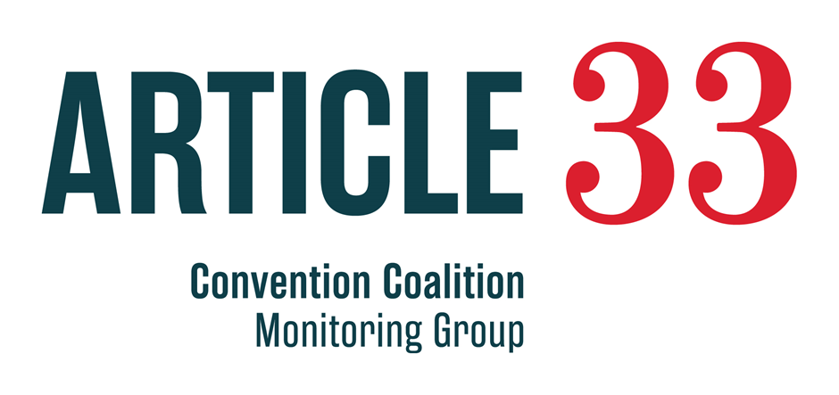
Disability Rights in Aotearoa New Zealand: Acceptance in Society
Easy Read version
A report on what disabled people in New Zealand say about their human rights

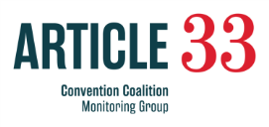
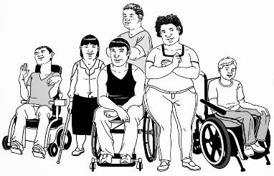
The Convention Coalition Monitoring Group (Convention Coalition) talked to disabled people in 2014.
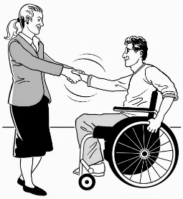
They spoke to 97 disabled people who lived in Auckland and Wellington.
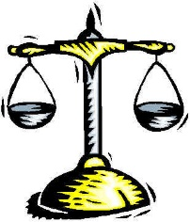
They wanted to find out if disabled people felt accepted by society.
This means that they are treated equally – in the same way as everybody else.
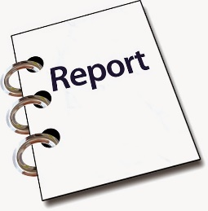
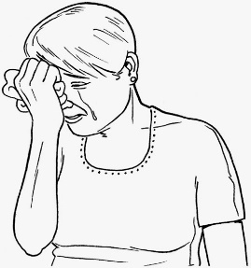
This short report tells you what the Convention Coalition found out about:
- when disabled people did not feel accepted
- when disabled people were being treated differently to non-disabled people
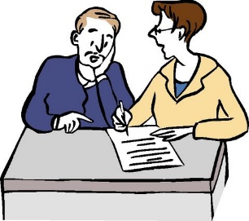
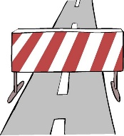
- barriers disabled people face that stop them feeling accepted.
Disabled people told the Convention Coalition about what had happened to them.
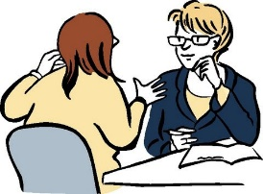
Disabled people talked about what stops them feeling accepted.

People and attitudes

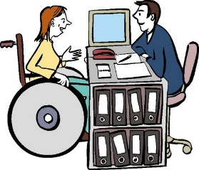
Disabled people told the Convention Coalition that people’s attitudes were stopping them feeling accepted.
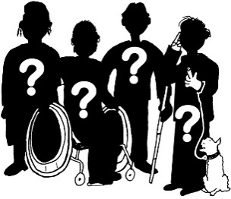
An attitude is the way people think and behave about something.
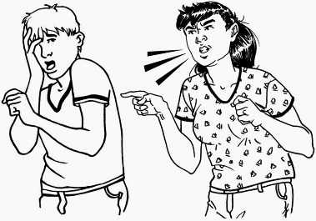
In this report it means what some people think about disabled people.
It also means how some people treat disabled people.
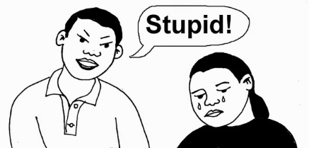
Some people:
- called disabled people bad names
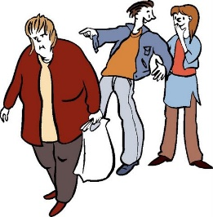
- made fun of disabled people
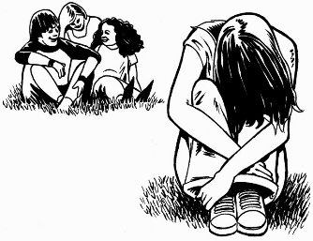
- made fun of peoples’ disability.
These attitudes made disabled people feel like they do not belong.
It stopped some people taking part in activities.
Disabled people told the Convention Coalition that some people think disabled people want more rights.
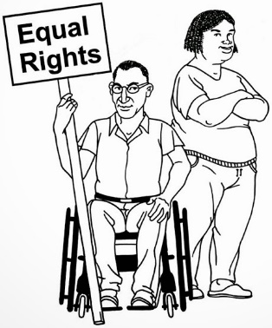
Disabled people do not want more rights.
They want the same rights as everybody else.
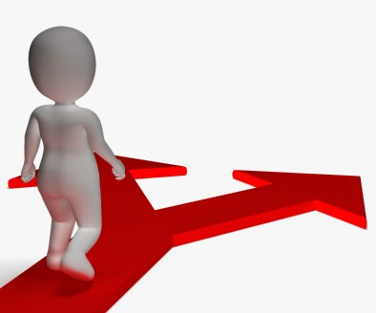
Disabled people thought it was easier for non-disabled people to live a good life.
Non-disabled people can make their own choices and decisions.
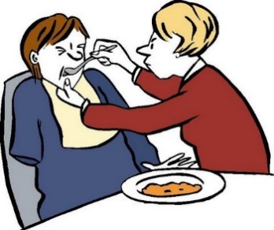
Some people thought that disabled people always needed help.
Some people treated disabled people like children that cannot make decisions for themselves.
Disabled people said these attitudes make it harder for disabled people to make their own decisions.

When people use services
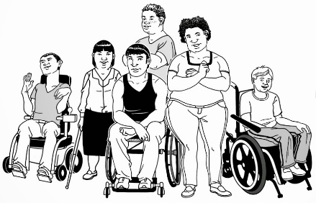
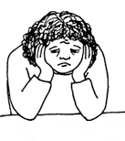
Disabled people told the Convention Coalition that people sometimes discriminate against them.
Discriminate means treating someone or a group of people unfairly.
It also means treating someone or a group differently to other people.
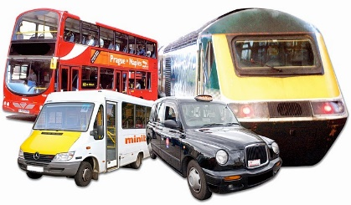
Disabled people said that they often faced discrimination when using public transport and taxis.
Public transport includes:
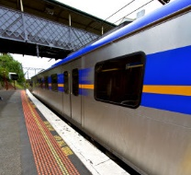
- buses
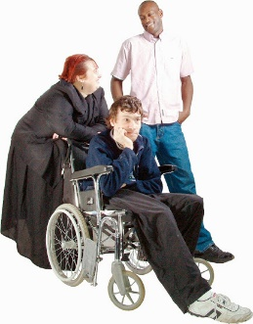
- trains.
Disabled people said sometimes buses, trains and taxis did not take disabled people.
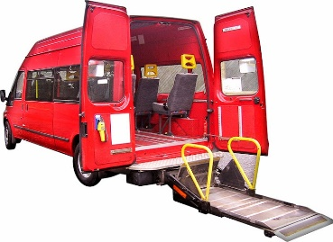
Disabled people said that there were not many mobility taxis.
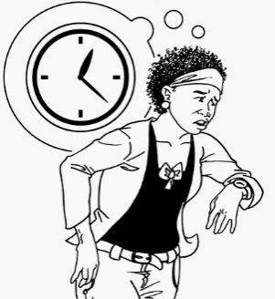
It was a big worry when there were no mobility taxis to use, like at the time children go to and from school.
Disabled people also said that mobility taxis cost more than other taxis.
This is 1 way of treating disabled people differently to non-disabled people.
Treating disabled people differently is discrimination.

When people go shopping
Disabled people said they were treated differently to non-disabled people when they went shopping.
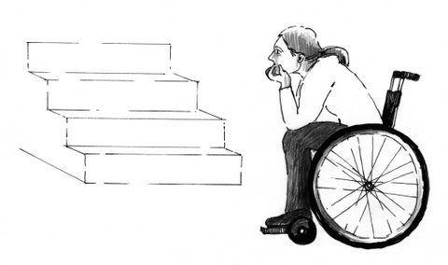
They also said that:
- some shops were hard to get around in because there was not enough space and other barriers
- it was hard to find their way around inside some shops

- some shop staff did not think disabled people can go shopping alone
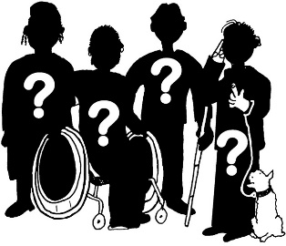
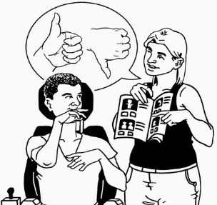
- some shop staff think that disabled people cannot make their own choices about buying things.
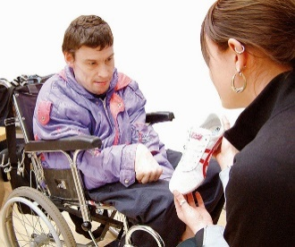
People who work in shops need to learn more about disabled people.
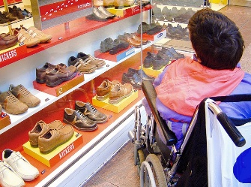
This would help people who manage and work at shops to help make disabled people feel accepted.
Disabled people should be able to shop the same way as everyone else.

In the community
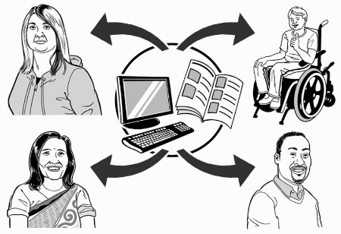
Disabled people from different cultural groups said that they did not feel accepted in their community.
Young people talked about belonging to more than one community, including online communities.
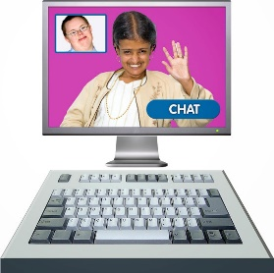
It is important for everyone to feel accepted, even online.
Disabled people said it was important that they are treated fairly online.
Disabled people said that sometimes when they used the internet:
- bad words were used online about disabled people
- disabled people were labelled or seen as different.

The way things are done
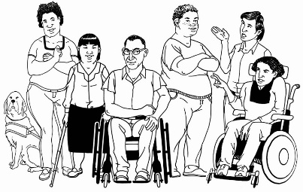
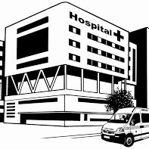
Disabled people told the Convention Coalition about examples of when a system, policy or process was unfair.
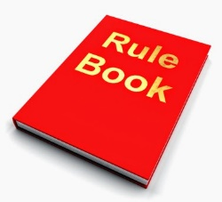
A system can be the way things are done at a place like a hospital.
A policy is a set of rules.
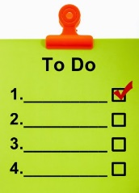
It tells a service how something should be done.
A process is the steps needed to be taken to get something done.
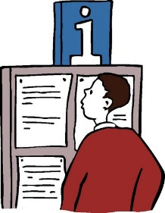
Disabled people sometimes found it difficult to:
- find information
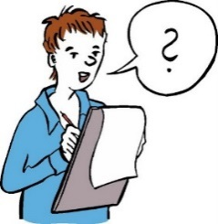
- understand how the system / policy / process worked
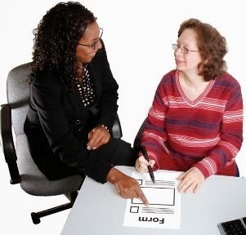
- use some support services.
They also worried that sometimes decisions were being made without people knowing all the information they should.
Being able to get information would help disabled people to deal with systems and policies that were hard to work out.
Some disabled people were worried about the legal system.
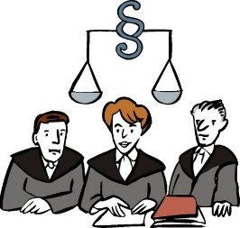
They think that the legal system treats disabled people unfairly because of their disability.
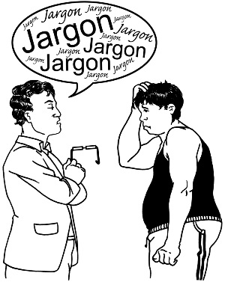
The courts and people who work there need to learn that:
- discrimination does happen due to disability

- disabled people do have different needs.

Being a citizen
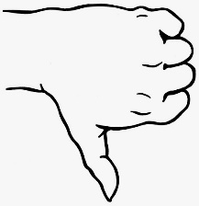
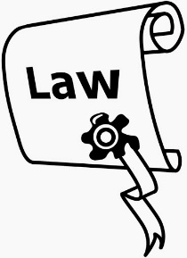
Disabled people told the Convention Coalition they felt like less of a citizen because of the bad things that had happened to them.
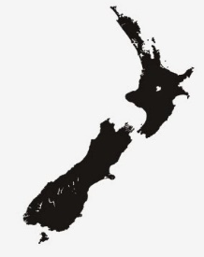
A citizen is somebody who legally belongs to a country.
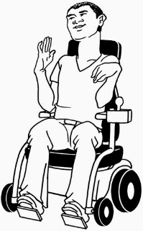
A New Zealand citizen is somebody who belongs in New Zealand.
The bad things that happened to disabled people often happened because they are living with a disability.
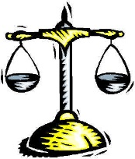
Disabled people said they were treated differently because of their disability.

Telling someone when bad things happen
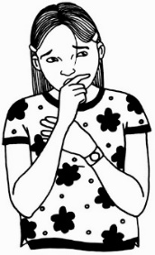
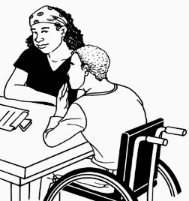
Most disabled people who said something bad had happened did not tell anybody about it.
Some disabled people did tell someone when something bad happened.
People said when they spoke up about bad things happening most of the time it was fixed.
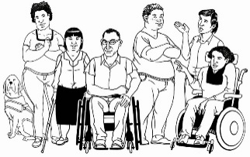
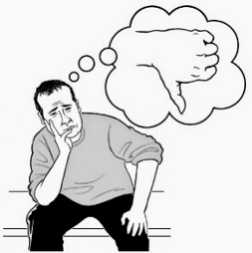
Disabled people were worried about telling someone that something bad had happened because:
- they thought no one would believe them
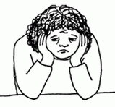
- they knew the treatment was unfair but did not know about their rights.
Many disabled people found it hard to stand up to people or tell someone when something was going wrong.
The Convention Coalition found out the same things in their 2012 Youth Report.
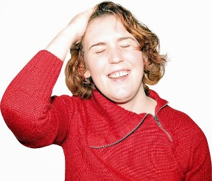
Young disabled people did not:
- do something about unfair treatment
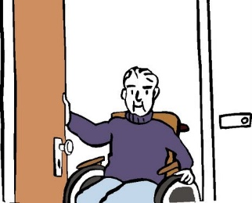
- did not know about their rights.
Disabled people felt that non-disabled people needed to know more about disabled people.
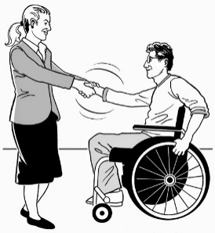
This would help them to understand disabled people.
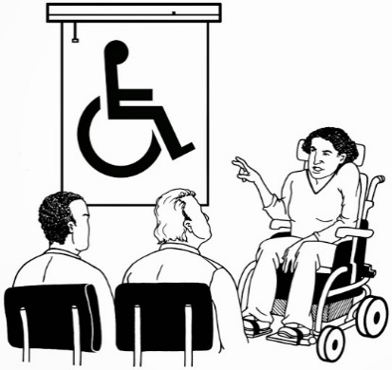
This could be done by:
- education – teaching people about disabled people and their disabilities
- making people more aware about disabled people by letting people know about disabled people and who they are.
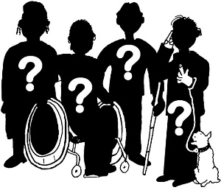
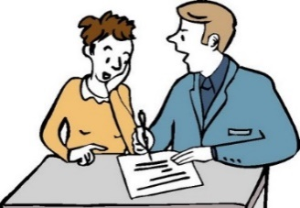
Disabled people wanted to be asked about their needs.
They did not want other people to think they knew what disabled peopled needed.
This needs to come from disabled people.
It would make things fair if more people talked to disabled people and found out what they needed.

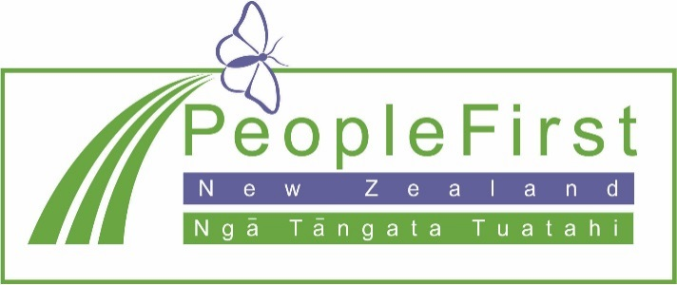

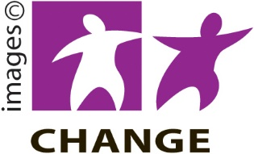
This has been translated into Easy Read in consultation with People First New Zealand Inc. Ngā Tāngata Tuatahi

