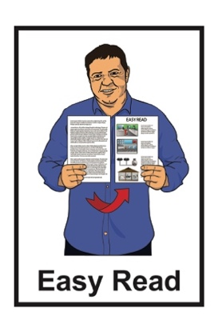

Easy Read information about

Disabled Persons Assembly New Zealand

Published: May 2023

About Disabled Persons Assembly

New Zealand

Disabled Persons Assembly New Zealand is called DPA for short.
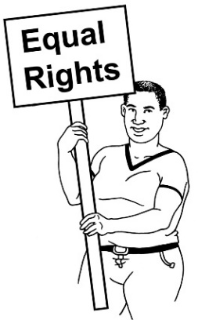

We work to make sure that disabled people have the same rights as everybody else.

We are:
pan-impairment which means the work we do is for all disabled people
not for profit which means any money we make goes into our work.

We are also a Disabled People’s Organisation which means we are run:

- by disabled people

- for disabled people.

Our governance / staff members are mostly disabled people.

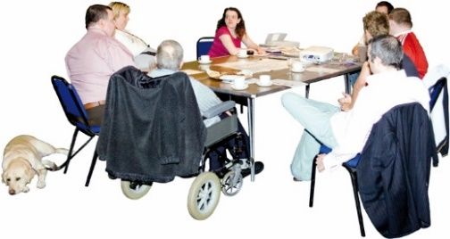
The DPA National Executive Committee makes decisions about what:
- we want to do
- how we are going to do it.

They are also called the NEC.

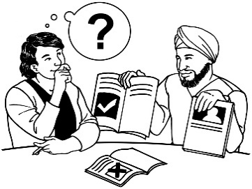
The work we do includes:
giving information / advice
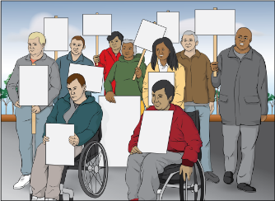
speaking up as a community of disabled people
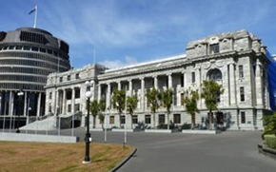
looking at what the Government needs to do to make things better for disabled people
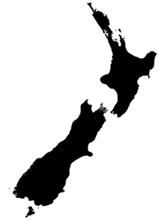
speaking up about what disabled people think:

- in local areas
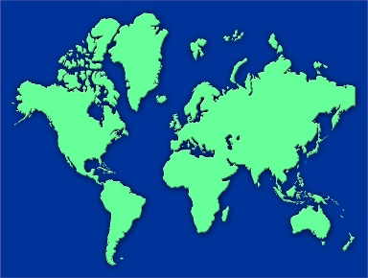
- across New Zealand

- around the world.

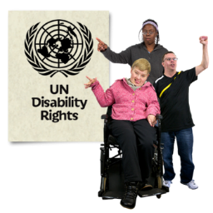
All the work we do is guided by the:
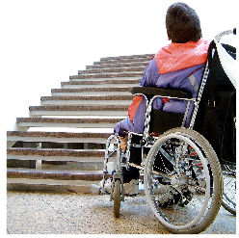
- United Nations Convention on the Rights of Persons with
Disabilities / UNCRPD
- social model of disability
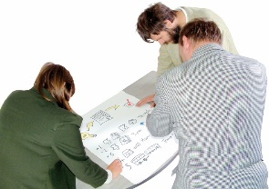
- New Zealand Disability Strategy.

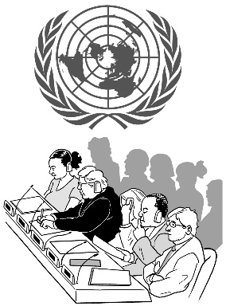
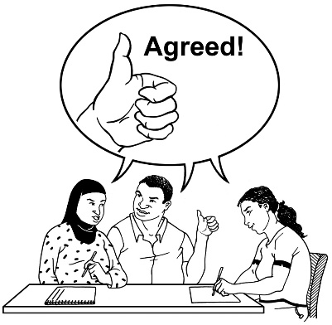
The United Nations Convention on the Rights of Persons with
Disabilities is a law lots of countries have agreed to.

The United Nations Convention on the Rights of Persons with Disabilities is also called the UNCRPD.

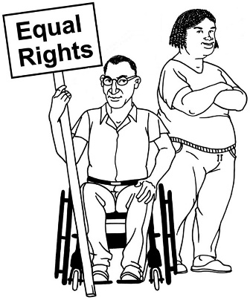
The UNCRPD says what governments must do to make sure disabled people get the same rights as everybody else.

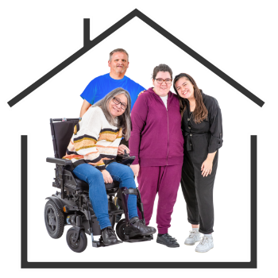
Rights are the things everyone should have to live a good life like:
- a safe place to live
- food to eat
- good medical care.
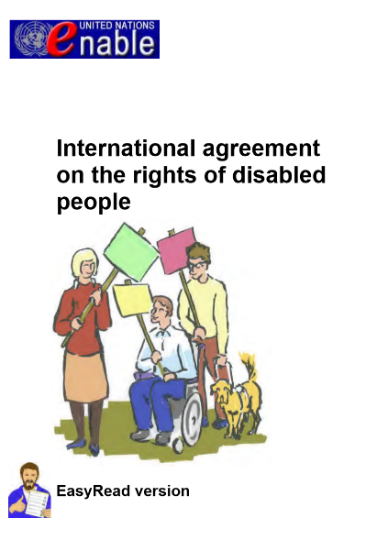
You can find out more about the UNCRPD in an Easy Read document called:

International agreement on the rights of disabled people.

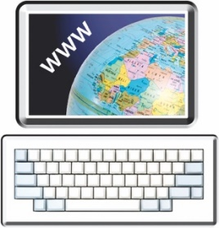
You can find this document at this website:

https://tinyurl.com/29n8wc6e
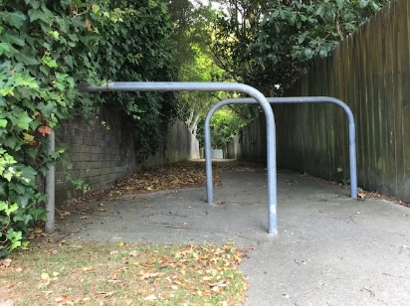
The social model of disability says that the problem is the barriers that make it harder for disabled people to have a good life.

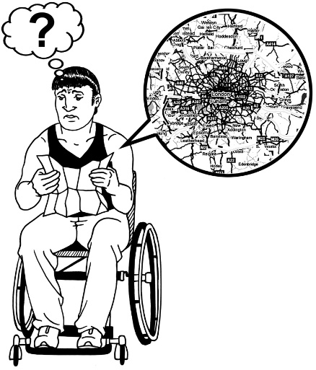
The problem is not:
disabled people
how their bodies work.

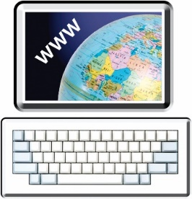
You can read more about the social model of disability at this website:

https://tinyurl.com/4p37fvru
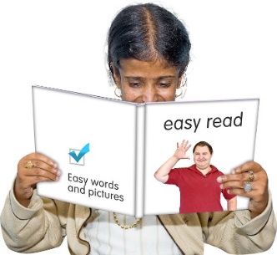

This page is not in Easy Read.

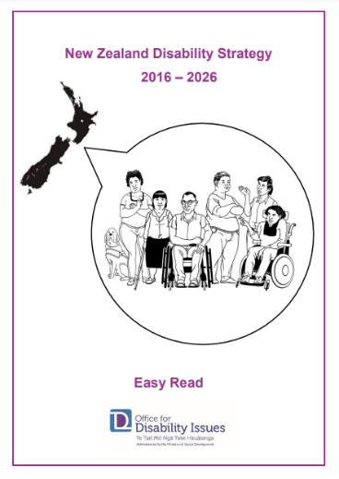
The New Zealand Disability Strategy is a plan for what the government is going to do about disability issues.

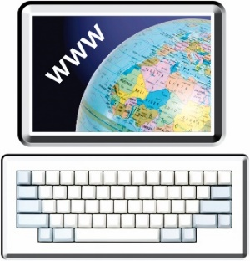
There is an Easy Read translation of the New Zealand Disability strategy at:

https://tinyurl.com/yvmdupz7

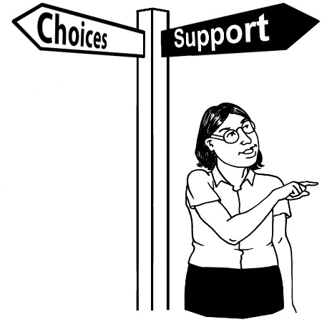
We think that in their lives disabled people can have:
more choice
more control
the support they need.

We also follow:
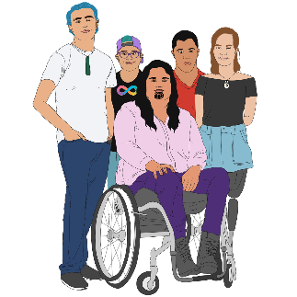
the ideas of Enabling Good Lives
Whāia Te Ao Mārama – Māori Disability Action Plan
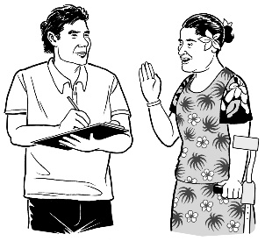
Faiva Ora – National Pasifika Disability Plan.

Enabling Good Lives is a way disabled people have more choice about their support.
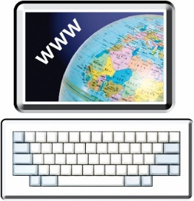

You can find out more about the Enabling Good Lives ideas in an Easy Read document at:
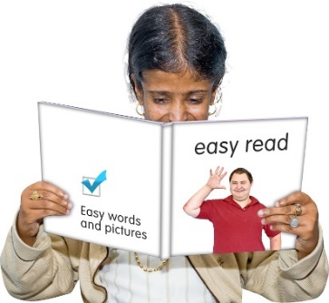
www.dpa.org.nz/store/doc/EGL-vision-and-principles-Easy-Read.pdf

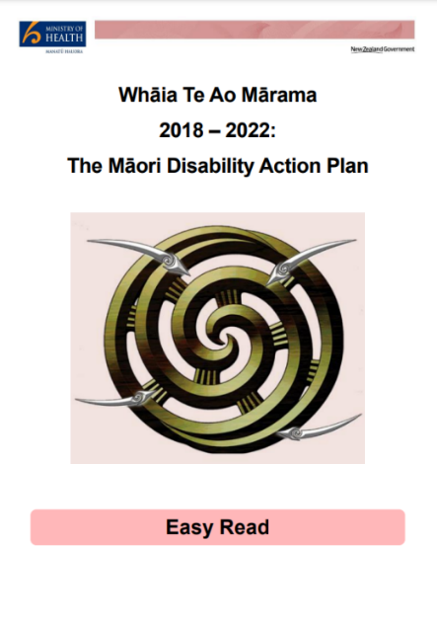
You can find an Easy Read translation of Whāia Te Ao Mārama – Māori Disability Action Plan at:

https://tinyurl.com/mvjtfzmw

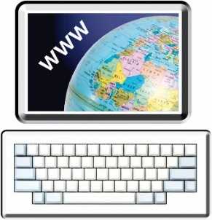
You can find Faiva Ora – National Pasifika Disability Plan at this website:

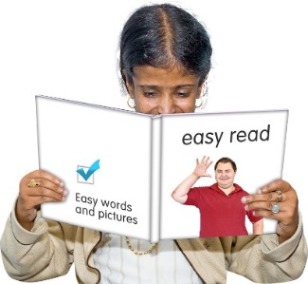
https://tinyurl.com/3b7f7j4b

This document is not in Easy Read.

How we do our work

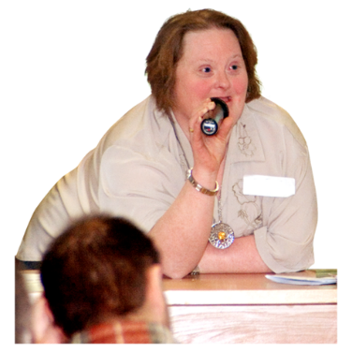
We work to make sure that disabled people have the same rights as everybody else through:

- leadership which means we speak up about what disabled people think:
- in local areas
- across New Zealand
- around the world.
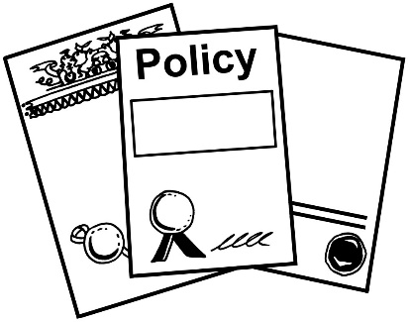
- information and advice about what affects the lives of disabled p eople like:
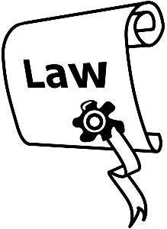
- government policies
- laws.
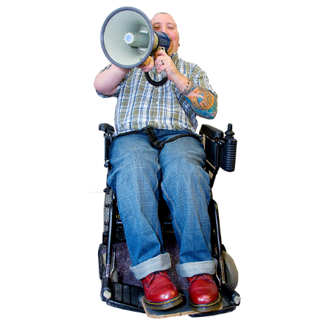
We also work to make sure that disabled people have the same rights as everybody else through:
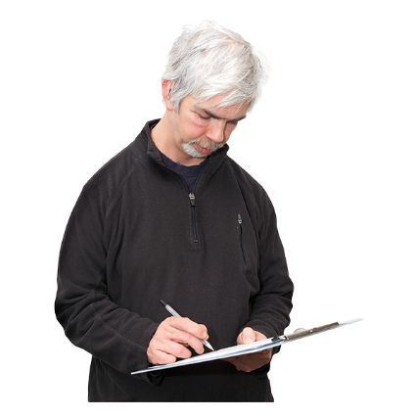
- advocacy which means we support disabled people to speak up as a community of disabled people
- monitoring which means we watch what the government is doing to make things better for disabled people.

Where to find more information

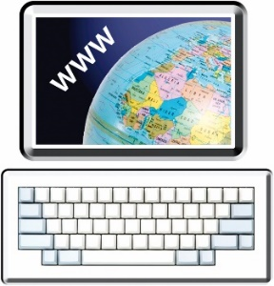
You can find more information about DPA on our website at:

www.dpa.org.nz

You can also contact us:
by phone on:
04 801 9100
by email at:
info@dpa.org.nz

This information has been written by Disabled Persons Assembly New Zealand.

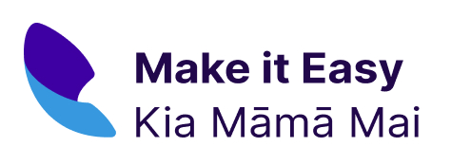
It has been translated into Easy Read by the Make it Easy Kia Māmā Mai service of People First New Zealand Ngā Tāngata Tuatahi.

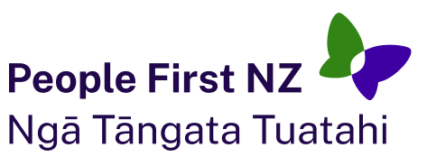
The ideas in this document are not the ideas of People First New Zealand Ngā Tāngata Tuatahi.

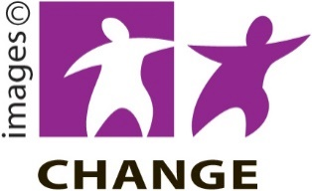
Make it Easy uses images from:

- Changepeople.org

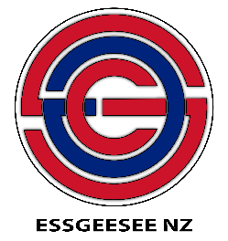
- Photosymbols.com

- SGC Image Works

- Huriana Kopeke-Te Aho.
All images used in this Easy Read document are subject to copyright rules and cannot be used without permission.

