Open Letter for Disability Justice in Climate Action

We, the undersigned, are writing this open letter as organisations involved in climate and environmental action in Aotearoa New Zealand, with the hope of making the climate movement more inclusive and accessible to those who are disproportionately harmed by the effects of climate change.

We recognise that the impacts of climate change will not be felt equally, and that these inequitable impacts will be disproportionately experienced by those who already face oppression and exclusion in our society. In particular, we recognise that disabled people in New Zealand and abroad are amongst the most impacted by climate change, and are also harmed by climate action that does not fully consider their rights and equal participation. This is exacerbated for those disabled people who are also members of other structurally oppressed communities, such as Indigenous Peoples, People of Colour, Migrants, and Sexual and Gender Minorities.

We recognise that action on infrastructure, especially transportation infrastructure, is necessary to meet our emissions reduction obligations – both internationally, in terms of our commitments under the Paris Agreement, but also locally in terms of our commitments to the needs and rights of communities at home.

However, we also understand that the built environment, and particularly transportation infrastructure, is inaccessible for many members of our communities who are disabled.

We therefore ask that all infrastructure projects, including green infrastructure and transport are fully accessible and uphold the rights of disabled people – including their participation and engagement in decision making and design.

We urge the New Zealand government to respect its commitments under the United Nations Convention on the Rights of Persons with Disabilities when considering infrastructure development, ‘Shovel Ready Projects’, and the Accessible Streets Package.

These projects must
“…enable persons with disabilities to live independently, and participate fully in all aspects of life… ensure to persons with disabilities access, on an equal basis with others to the physical environment, to transportation, to information and communications, including information and communications technology and systems, and to other facilities and services open to or provided to the public.”
(UNCRPD, Article 9)

Additionally, decision-making on these projects must include robust consultation and involvement of people with disabilities, per the United Nations Convention on the Rights of Persons with Disabilities:

“In the development and implementation of legislation and policies… and in other decision-making processes concerning issues relating to persons with disabilities, State Parties shall closely consult with and actively involve persons with disabilities, including children with disabilities, through their representative organizations.”
(UNCRPD, Article 4.3)

Ngā mihi,
Signed,
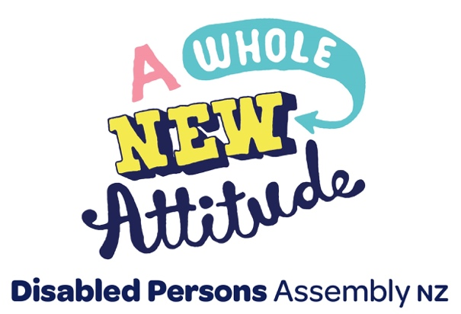

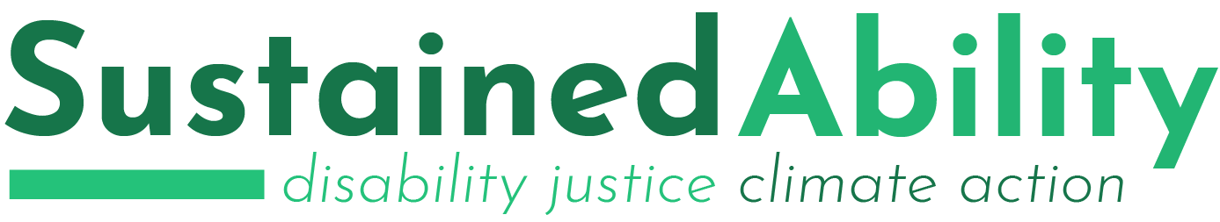

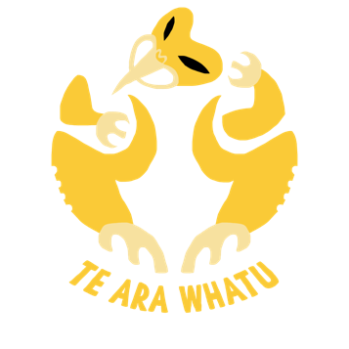
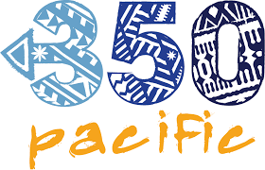

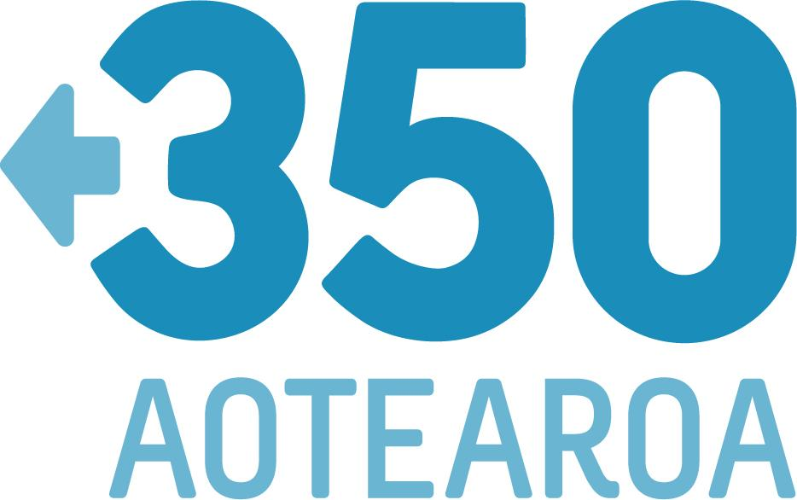

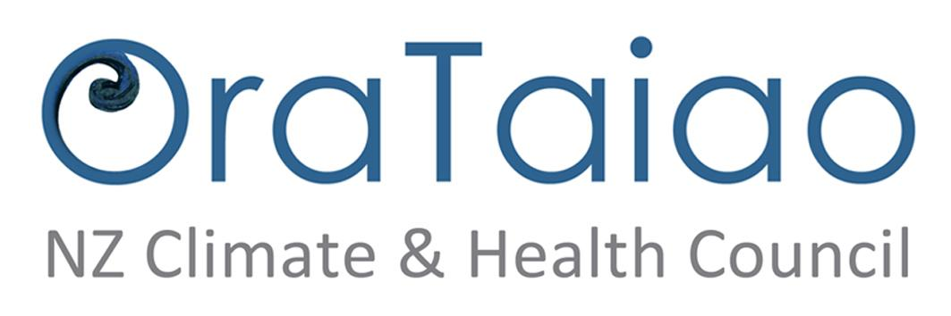

[Logos of Disabled Persons Assembly NZ, SustainedAbility, 350 Pacific, 350 Aotearoa, Oxfam, Greenpace, and OraTaiao: NZ Climate & Health Council ]

