## Updated numbers on disability from Stats NZ

We’ve looked at three recent information releases from Stats NZ – the Household labour force survey, the Household labour force survey – Wellbeing supplement, and the Household Economic Survey, to provide a summary of the results as related to the disabled.

As these figures are related, we present them all below.

You will note that we use the word “significantly” to describe some of the changes in the data. When we do that, we are reporting that the change is “statistically significant”.

## Employment & qualifications (Household labour force survey, December 2020)

* In recent years, there has been a gradual decline in unemployment rates among disabled people (13% in June 2017 which reduced to 8% in June 2020). However, the repercussions of COVID-19 can be observed after June, with unemployment rates among disabled people (aged 15-64) increasing to 11% in December 2020. Among disabled women for instance, unemployment rates had been reducing from 2017 to 2019, however post COVID-19, unemployment rates have risen to be significantly higher (at 15%) than that of unemployed disabled men (at 8% in December). In comparison, unemployment rates for the same period were at 5% among non-disabled men and women.

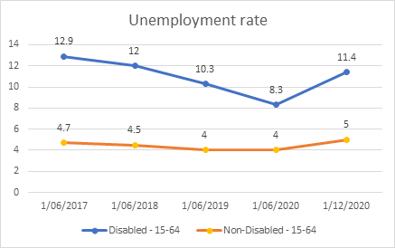

* The gap in employment rates between disabled men and women have been reducing, with 38% of disabled women being employed in December 2020, compared to 39% of disabled men.
* While underemployment rates have remained steady among non-disabled people (at 5%), this rate has reduced among disabled people (from 8% in June to 5% in December 2020).
* Post COVID-19, disabled women have had a higher labour force participation rate than disabled men (at 44% compared to 43% of disabled men). Among disabled people aged 15-24, labour force participation rates have increased significantly (from 23% in June to 33% in December). Likewise, this rate has also increased among non-disabled people (from 61% to 66%), although the increase has not been as substantial.

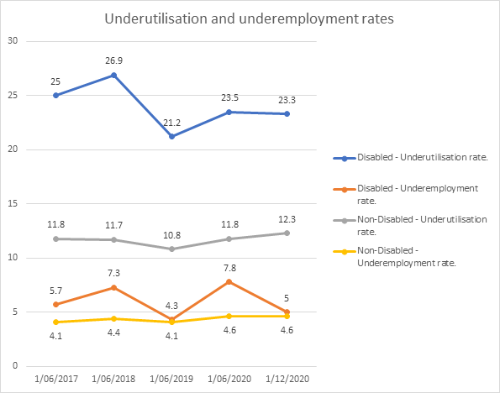

* From June to December 2020, the proportion of disabled people that noted their reason for leaving their last job (within the last 5 years) was due to being made redundant, laid off or had businesses closed has significantly increased from 6% to 11% among disabled people. Comparatively, this rate has increased from 10% to 12% among non-disabled people.

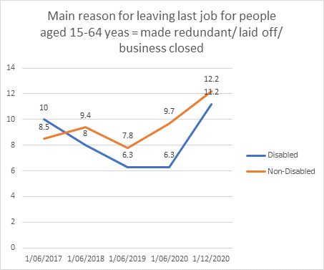

* There was a statistically significant reduction in the proportion of disabled people that were not in the labour force (aged 15-64) that were looking after a child (from 11% in June to 8% in December).
* Paid employees with a disability that do not have a written agreement has increased significantly from June 2020 (at 4% in June to 9% in December 2020). Comparatively, non-disabled paid employees that do not have a written agreement has remained stable (at 4%).
* From June 2020 to December 2020, the proportion of people aged 15-64 with the highest qualifications being post-school qualifications, dropped slightly among disabled people (43% to 40%), whereas this has increased among non-disabled people (55 to 57%).

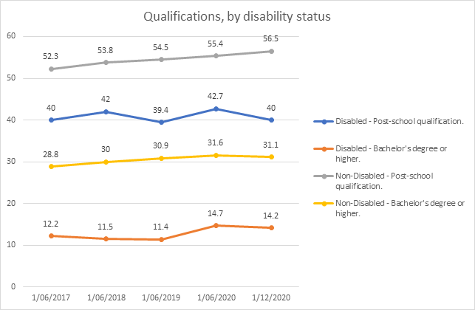

* For more information on the Household labour force survey, December 2020 visit the Stats NZ website [here.](https://www.stats.govt.nz/information-releases/labour-market-statistics-disability-december-2020-quarter)

## Wellbeing (Household labour force survey – Wellbeing supplement, December 2020)

* Overall life satisfaction has improved among disabled people aged 18-64 (from 56% in June to 61% in December reporting a score of 7 or more). Inequalities remain, with 87% of non-disabled population reporting the same scores in December.
* The proportion of disabled people reporting having enough or more than enough money to meet every day needs has reduced (for example from 45% to 39% among those aged 18-64). In comparison, the same measure reported among non-disabled people has remained stable (at 69 to 70%).
* An increased proportion of disabled people have reported receiving help from organisations such as a church or foodbank in the last 12 months (20% among those aged 18-64 in December, compared to 18% in June).
* Increased proportion of disabled people aged 18-64 have reported their general health status as being good, very good or excellent (58% compared to 54% in June).
* Disabled people (aged 18-64) reported being less happy (70% provided a score of 7 or more) compared to non-disabled people in the same age group (92% provided a score of 7 or more). Similarly, disabled people reported higher anxiety levels (23% compared to 14% among non-disabled people). This was a new measure, put into effect in December 2020.
* Increasing levels of loneliness has been reported among disabled people. 14% of disabled people aged 18-64 reported feeling lonely in the last four weeks most/all of the time, compared to 12% in June.  Comparatively, among non-disabled people, this has reduced slightly from 4 to 3%.
* Trust held for people in New Zealand has reduced among both disabled and non-disabled people across all age groups (e.g. 60% of disabled people aged 18+ providing a score of 7 and above in June 2020, dropping down to 56% in December 2020). In comparison, trust held for the health system has improved (56% of disabled people aged 18-64 providing a score of 7 and above in June 2020, increasing to 59% in December 2020).
* While trust in media and parliament among disabled people has increased post COVID-19, it comparatively has reduced among non-disabled people. For example, 22% of disabled people aged 18+ provided a rating of 7 and above relating to trust in media in June 2020. This proportion has increased to 25% in December 2020. Comparatively among non-disabled people in the same age group, this proportion has reduced slightly from 27% in June to 26% in December.
* Less disabled and non-disabled people have reported having problems with heating and/or keeping their house/flat warm in winter (e.g. 16% of disabled people in June 2020 reported having major problems with heating, which has reduced to 12% in December 2020).

For more information on the [Household labour force survey – Wellbeing supplement, December 2020 visit the Stats NZ website](https://www.stats.govt.nz/information-releases/wellbeing-statistics-december-2020-quarter).

## Child poverty Statistics (Household Economic Survey, June 2020)

* Across all measures, disabled children were more likely to live in a household with low-income and material hardship than non-disabled children
* Children living in a household with at least one disabled person were over twice as likely to experience material hardship than children in a household with no disabled people.
* 20% of disabled children were living in households in material hardship for the financial year, compared to 10% of non-disabled children. Māori and Pacific children were also more vulnerable, being more likely to live in households in material hardship (19% and 25% respectively) compared with European children (9%).
* After deducting housing costs, 32% of children in disabled households were living in low income households (less than 60% median equivalised disposable household income), compared to 28% of non-disabled children.
* 20% of children living in households with at least one disabled person were in material hardship for the financial year, compared to 7% of children in non-disabled households.
* 9% of disabled children are living in households in severe material hardship, compared to 4% of non-disabled children

For more [information on the Household Economic Survey visit the Stats NZ website](https://www.stats.govt.nz/information-releases/child-poverty-statistics-year-ended-june-2020)